**AAS - Designer Manual**

***TP 12 – „Produktkatalog“***

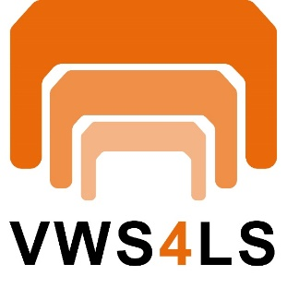



Table of Contents

Table of Contents 2

1 Getting Started with AAS Designer 4

1.1 Login 4

1.2 User registration 5

1.3 Version Information 6

2 AAS-Designer Overview 8

3 AAS Server Selection 9

3.1 For Admin Users 9

3.2 For Users with Lower Privileges 10

4 Operating the Tree Structure 11

4.1 Inserting elements 13

a. Operating the Elements in AAS 14

4.2 Property 16

4.2.1 “Details” 18

4.2.2 “Content” 18

4.2.3 “Semantic Description” 18

4.2.4 “Qualifier” 19

4.2.5 “Data Definition” 19

4.3 Range 22

4.3.1 “Content” 22

4.4 SubmodelElementList 22

4.4.1 “Details” 23

4.4.2 “Semantic Description” 23

4.4.3 “Qualifier” 24

4.4.4 “Data Definition” 24

4.5 SubmodelElementCollection 25

4.5.1 “Details” 25

4.5.2 “Semantic Description” 26

4.5.3 “Qualifier” 26

• Custom Qualifiers 27

• Cardinality 27

4.5.4 “Data Definition” 27

5 Overview of AAS Shells 29

5.1 View 30

5.2 Modify 31

5.3 Delete 32

5.4 Advanced 33

5.4.1 Create Feed Mapping 33

5.4.2 Duplicate 33

5.5 Exports 34

5.6 Create Link for Sharing 34

6 AAS-Designer Features 36

6.1 Dashboard 36

6.2 Packages 36

6.3 Create AAS 37

6.4 IDTA Submodels 38

6.5 My Area 39

6.6 Feed Mapping 39

7 Identification Schemas and their Importance 41

7.1 UUID/GUID 41

7.2 IRDI (ISO 29005-5) 42

7.2.1 Understand the IEC IRDI Structure 43

7.2.2 Understand the ECLASS IRDI Structure 43

7.3 URI/IRI 45

8 Semantic Databases 46

8.1.1 IEC-CDD 47

8.1.2 ECLASS 50

8.1.3 VEC 51

9 Add Semantic References to the Entities of AAS Shell 55

9.1 Submodel 55

9.2 Property Value 56

10 Concept Description 58

11 Literaturverzeichnis 59

12 List of Figures 63

# **Getting Started with AAS Designer**

Follow the following steps to get started with AAS Designer.

**Step 1**: Visit [www.google.com](http://www.google.com/) and type AAS Suite. Click on the first option.

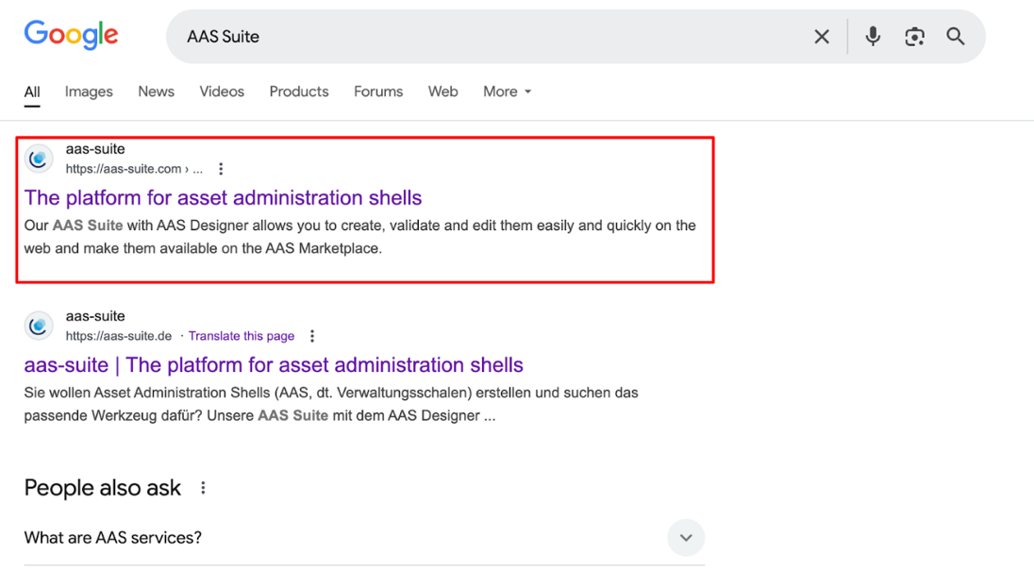

Figure 1‑1: Accessing AAS Designer via Google Search

**Step 2**: To proceed, scroll down the website until you find the link highlighted in the image below. Once you locate it, click the button.

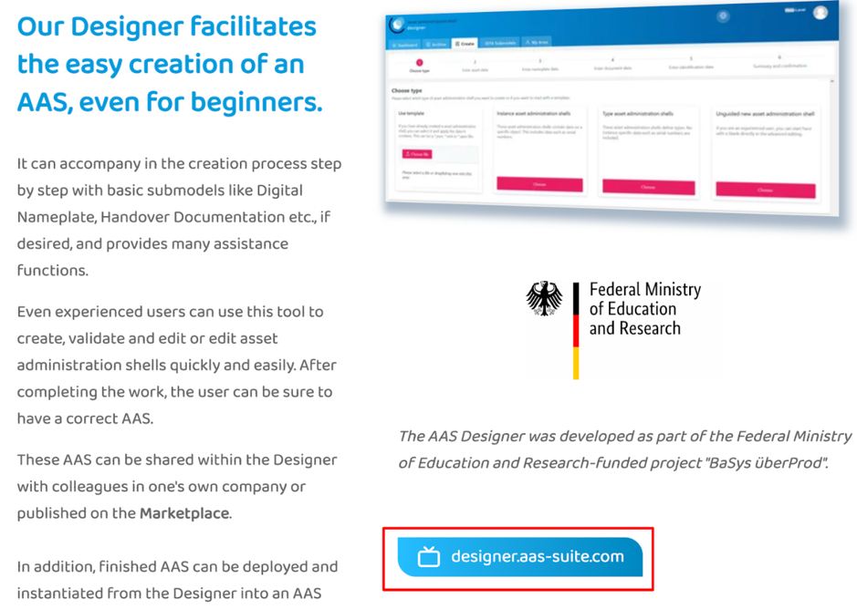

Figure 1‑2: Navigating to the AAS Suite Designer

## Login

**Step 3**: After clicking the link, you will be redirected to the login page. Once logged in, you will be taken to the AAS Suite Dashboard. On the Login Page, you can click on "Show T&C" to view the General Terms and Conditions of AAS Suite provided by Meta-Level Software AG, along with relevant pricing details.

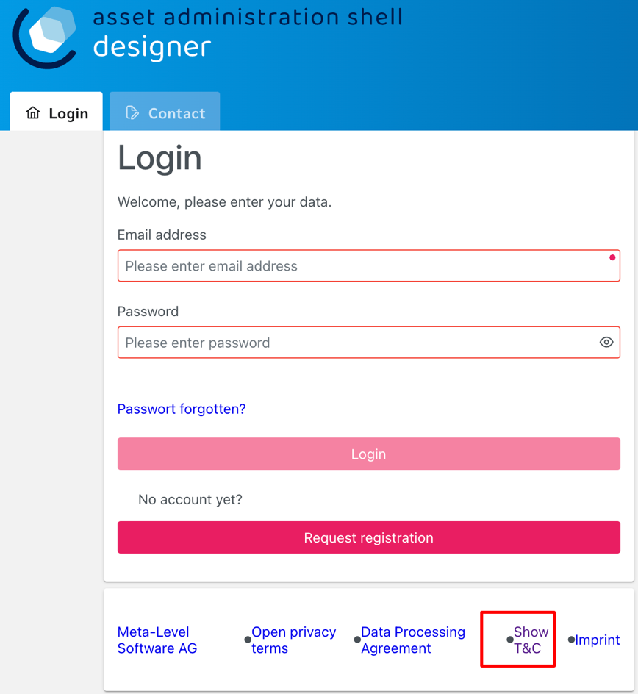

Figure 1‑3: Logging into the AAS Suite Designer

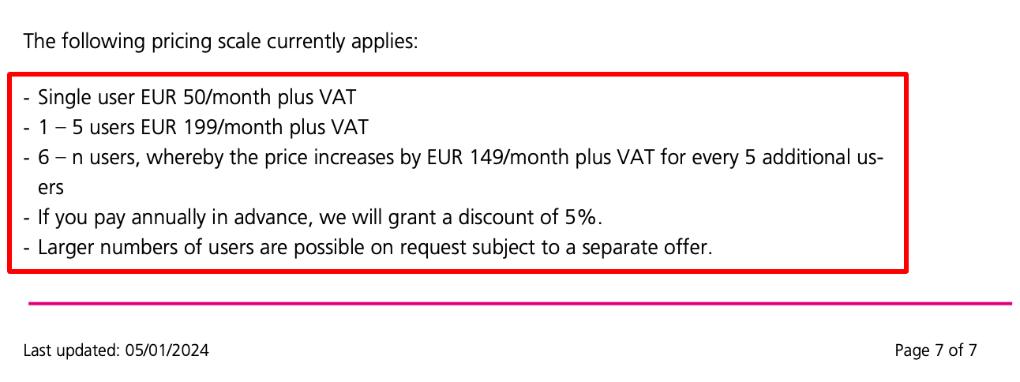

Figure 1‑4: Screenshot of Pricing and Terms in AAS Suite

## User registration

If you're not already registered, you can click on "Request Registration". This will redirect you to the registration page, where you can fill out the registration form to create your account and gain access to the AAS Suite. Once registered, you can log in and proceed with using the platform as needed.

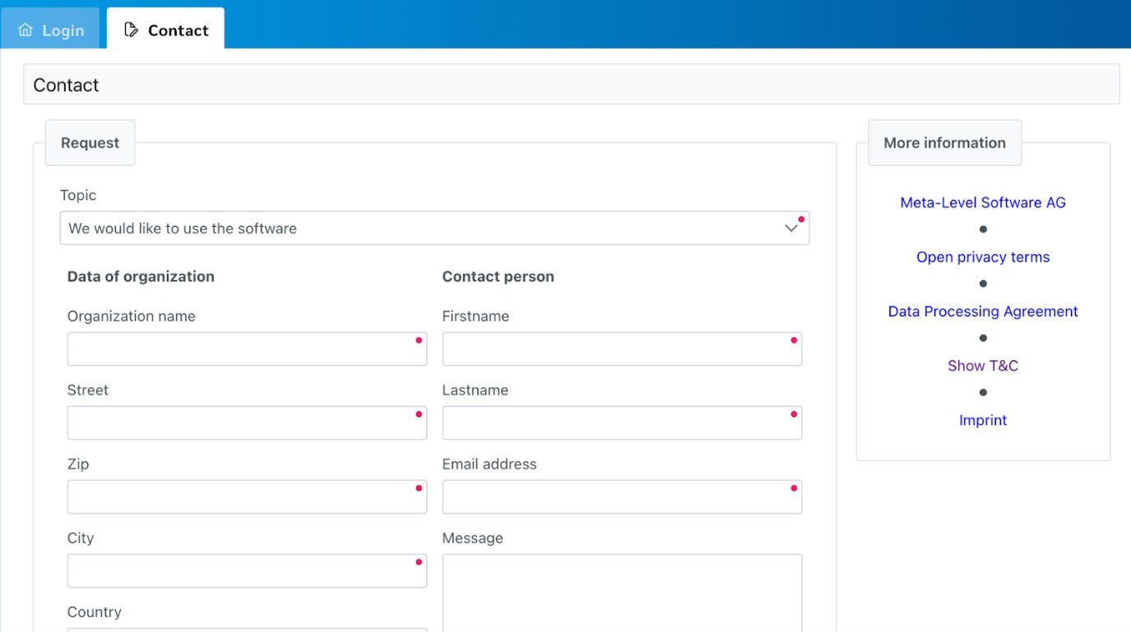

Figure 1‑5: Registration Page for AAS Suite

## Version Information

To view the version number, click on the highlighted profile section at the top right of the page.

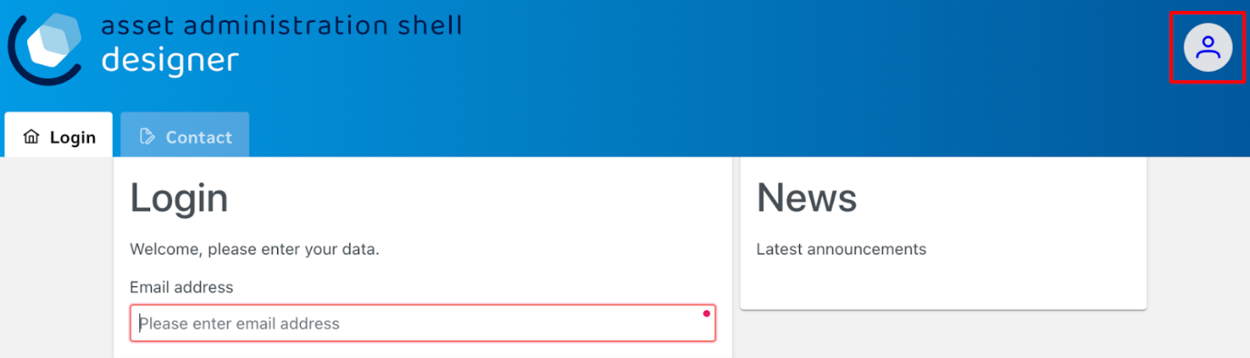

Figure 1‑6: Accessing AAS Suite Version Details

You can see that the version number of the software displayed above is 8. This indicates the current version of the AAS Suite you're using.

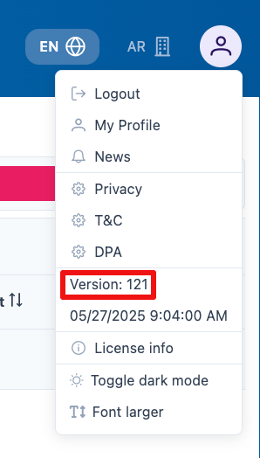

Figure 1‑7: AAS Suite Version Information

By clicking on License Info, you can access additional details such as the License Name, Copyright Information, and the Validity period of your current license.

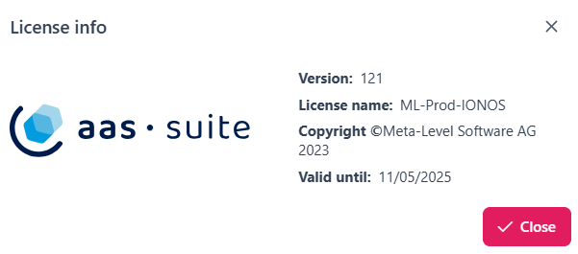

Figure 1‑8: AAS Suite License Information

# **AAS-Designer Overview**

The [AAS Suite](https://aas-suite.com/en) is a comprehensive platform designed to simplify the creation, validation, and sharing of Asset Administration Shells (AAS) in Industry 4.0 environments. It includes multiple tools such as the [AAS Designer](https://designer.aas-suite.com/), which enables users to create, edit, and validate AAS with ease, and the [AAS Marketplace](https://market.aas-suite.com/), where AAS can be shared and accessed. Additional tools like the Viewer, Reader, Feed Application, and [Compare Tool](https://compare.aas-suite.com/) further enhance AAS management and usability.

The AAS Designer is a user-friendly tool that caters to both beginners and experts. It provides step-by-step guidance for creating administration shells with essential submodels, such as the digital nameplate and handover documentation, while also offering an expert mode for advanced users to efficiently create, validate, and edit AAS. Users can collaborate with their company by sharing AAS through the Designer or publish them on the AAS Marketplace. Also, AAS can be deployed and instantiated into an AAS registry or repository system directly from the Designer. The AAS Designer addresses this challenge by offering automated assistance, a guided workflow, and an expert mode for advanced users, ensuring error-free AAS creation.

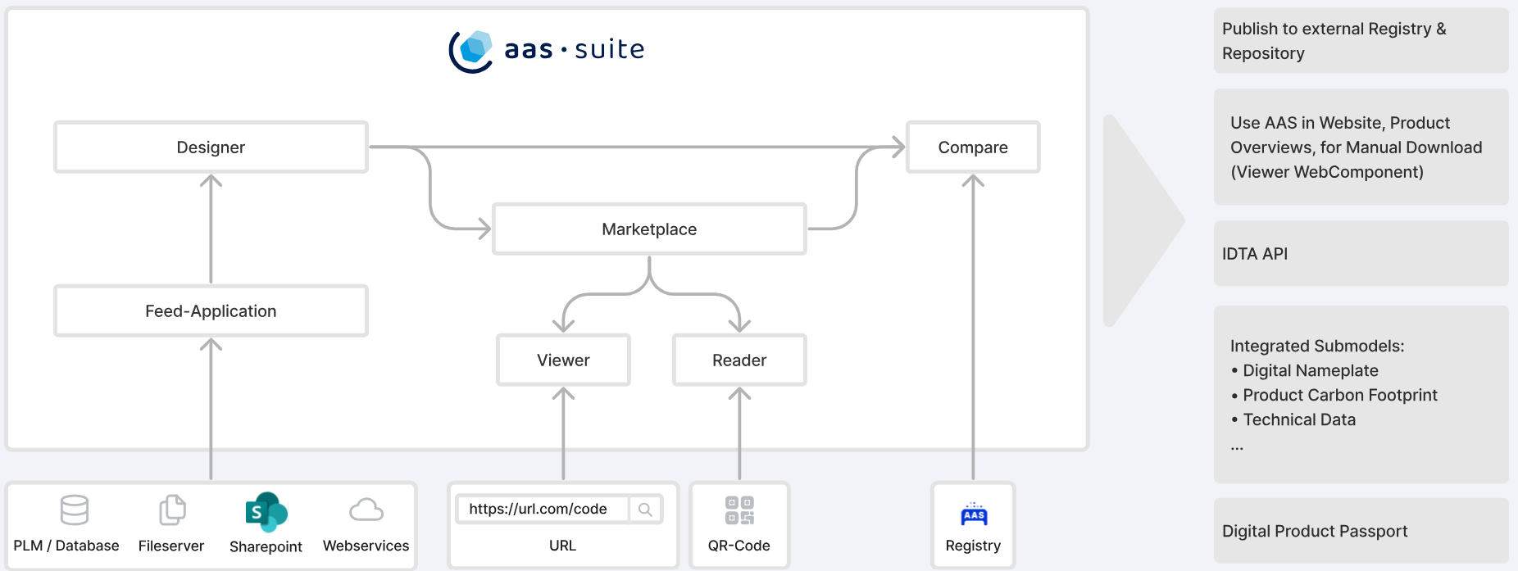

Figure 2‑1: Overview of [AAS Suite](https://aas-suite.com/en) Platform

The [AAS Designer](https://designer.aas-suite.com/) consists of several key components: *Dashboard*, *Shells*, *Concept Description, Create*, *IDTA Submodels*, *Instance Viewer, My Area*, and *Feed Mapping*. Each of these plays a role in the creation and management of Asset Administration Shells. We will explore these components in detail in the upcoming chapters.

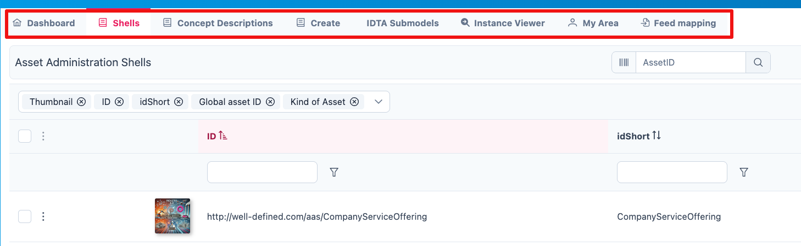

Figure 2‑2: Key Components in AAS-Designer

# **AAS-Designer Features**

## Dashboard

The AAS-Suite provides various sections that help users manage and interact with Asset Administration Shells (AAS), such as the *Dashboard*:

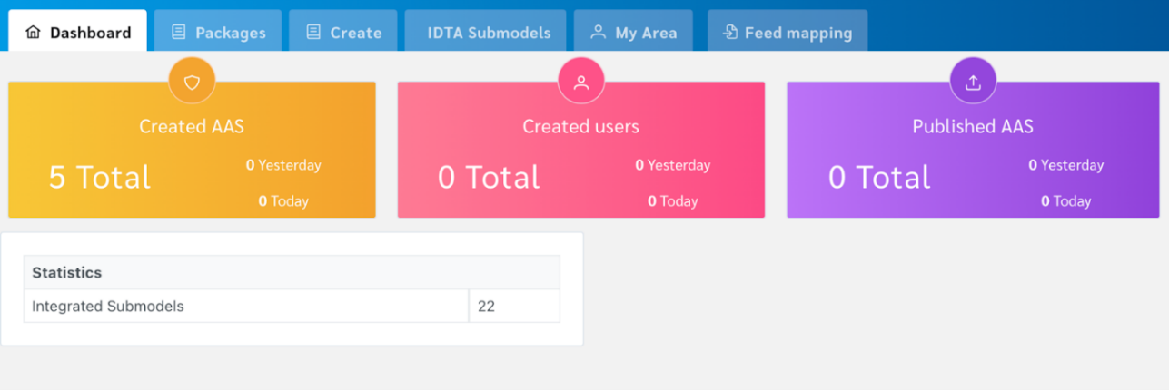

Figure 3‑1: AAS Suite Dashboard Section

This section displays key statistics and information about your activities in the AAS Suite:

* Created AAS: Shows the total number of AAS shells you’ve created. You can see the overall total, as well as how many were created yesterday and today.
* Created Users: Displays the number of users who have created AAS shells, with a breakdown of total, yesterday, and today.
* Published AAS: This shows how many AAS shells have been published, with the same daily breakdown as above.
* Statistics: Displays statistics about integrated submodels.

## Shells

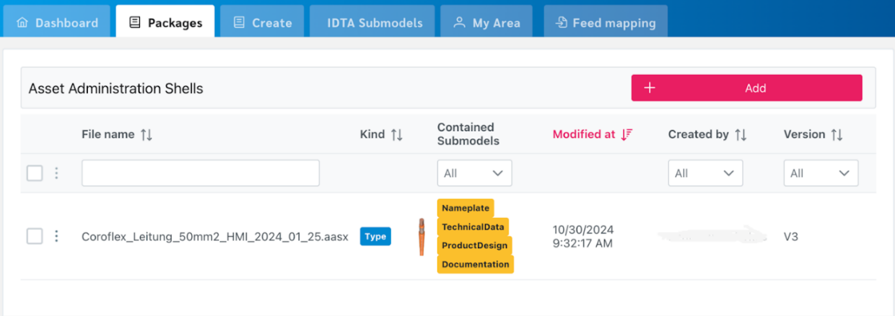

Figure 3‑2: Packages Section in AAS Suite

The Shells section lets you manage AAS-related shellss:

* This part provides a list of the AAS shells you have. Each AAS may contain various submodels like Nameplate, TechnicalData, and Handover Documentation. It shows additional information such as the last modified date, creator, and version of the package.

## Concept Description

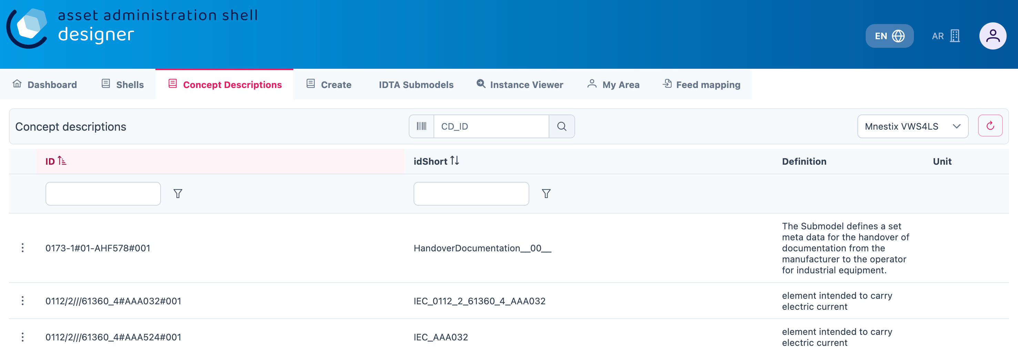

Figure 3‑3: Concept Description in AAS Suite

All concept descriptions added to various shells are displayed on this page. Each concept description includes the **ID**, **idShort**, **Definition**, and **Unit**. You can modify or delete any concept description directly from this page.

This feature is especially helpful in identifying redundancies and unused concept descriptions—those created within shells but not referenced in any semantic descriptions. It enables easier tracking, management, and cleanup of such entries.

## Create

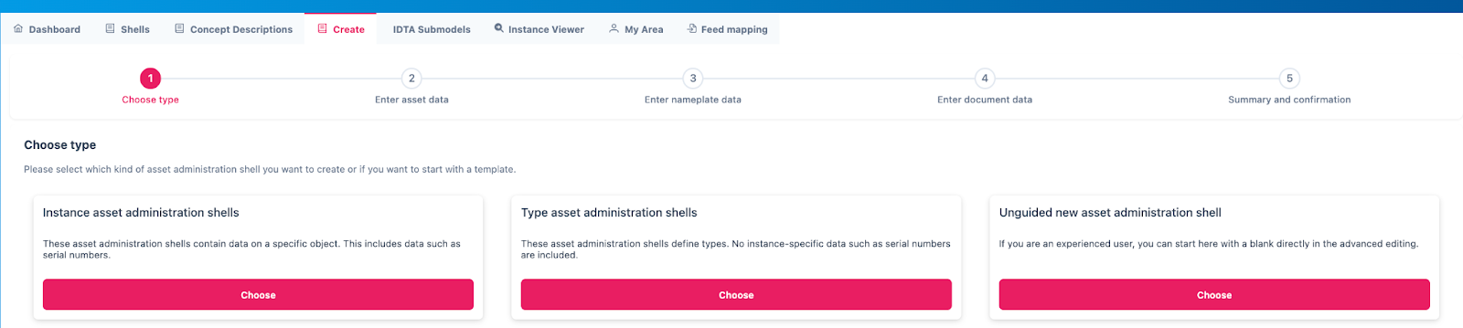

Figure 3‑4: Choose Type under Create in AAS Suite

There are several options for creating different types of AAS:

Select the type of asset administration shell to create or choose a template.

* Use Template: If you’ve created an AAS before, you can use its data (.json, .xml, or .aasx) to create a new one by selecting the file
* Instance Asset Administration Shells: Create AAS for a specific object, such as an asset with unique data (e.g., serial numbers).
* Type Asset Administration Shells: These define types of assets and do not include instance-specific data like serial numbers.
* Unguided New AAS: For experienced users, this option lets you start from scratch in advanced editing mode.

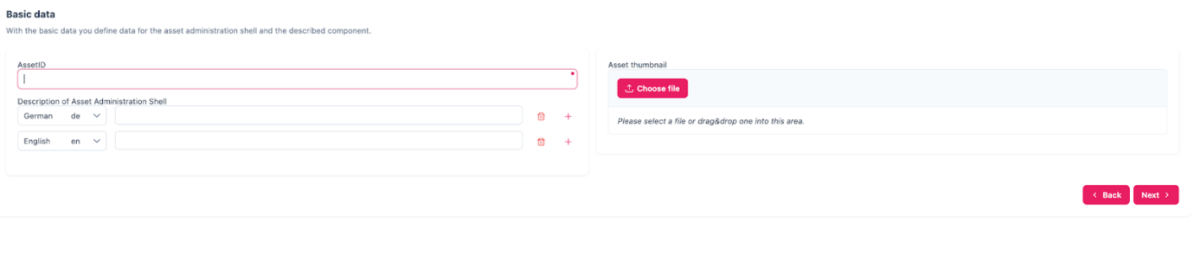

Figure 3‑5: Entering asset data under Create

Enter basic information related to the asset and its shell:

* Asset ID – Unique identifier for the asset
* Description – Brief overview of the asset or its purpose
* Asset Thumbnail – Upload or drag-and-drop an image to represent the asset visually

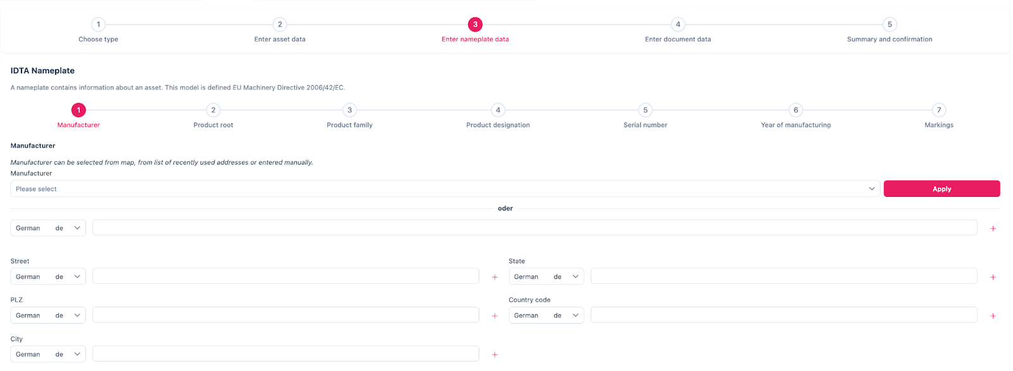

Figure 3‑6: Entering nameplate data under Create

The **IDTA Nameplate** contains mandatory identification details based on EU Machinery Directive 2006/42/EC:

1. Manufacturer
2. Product root
3. Product family
4. Product designation
5. Serial number
6. Year of manufacturing
7. Markings

**Manufacturer Information:** Can be selected from the map, a list of recently used addresses, or entered manually:

* Manufacturer Name
* Street
* Postal Code (PLZ)
* City
* State
* Country Code

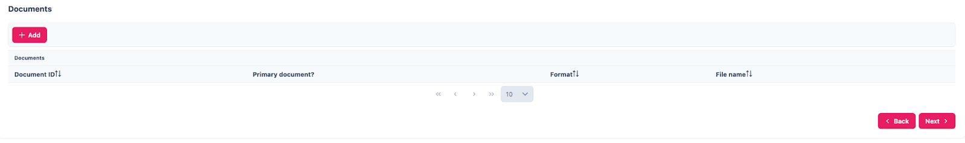

Figure 3‑7: Entering Document data under Create

Provide document-related information:

* Document ID
* Primary Document? (Yes/No)
* Format (e.g., PDF, DOCX)
* File Name

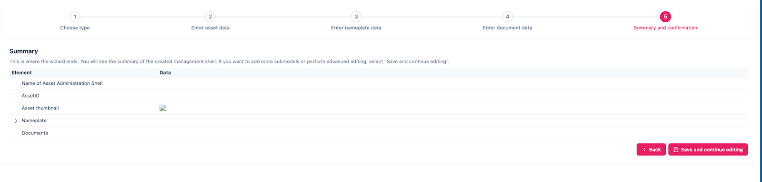

Figure 3‑8: Providing Summary and Confirmaton under Create

This final step summarizes the information entered. Click **"Save and continue editing"** if you want to add more submodels or perform advanced editing.

## IDTA Submodels

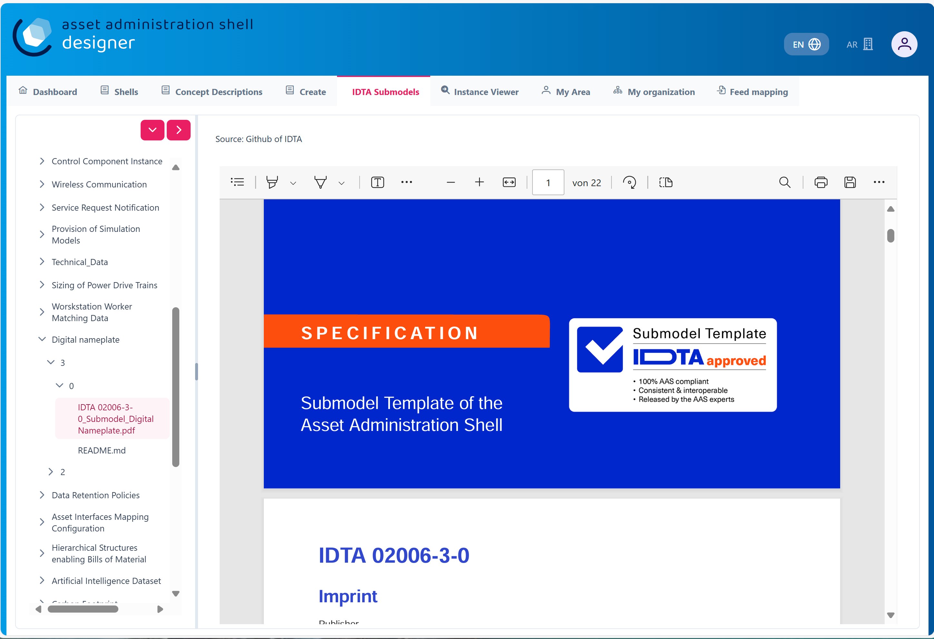

Figure 3‑9: IDTA Submodels in AAS Suite

This section displays available *submodels*, typically from the Industrial Digital Twin Association (IDTA). The *submodels* represent different components and aspects of AAS. Some examples of *submodels* include:

* [DEXPI](https://industrialdigitaltwin.io/idta-submodel-templates/dexpi/1.0/index.html)
* [HandoverDocumentation](https://github.com/admin-shell-io/submodel-templates/tree/main/published/Handover%20Documentation/1/2) [1]
* [Wireless Communication](https://github.com/admin-shell-io/submodel-templates/tree/main/published/Wireless%20Communication/1/0)
* [Data Model for Assess Location](https://github.com/admin-shell-io/submodel-templates/tree/main/published/Data%20Model%20for%20Asset%20Location/1/0)
* [Functional Safety](https://github.com/admin-shell-io/submodel-templates/tree/main/published/Functional%20Safety/1/0)

You can integrate these *submodels* into your AAS depending on the data needs.

## My Area

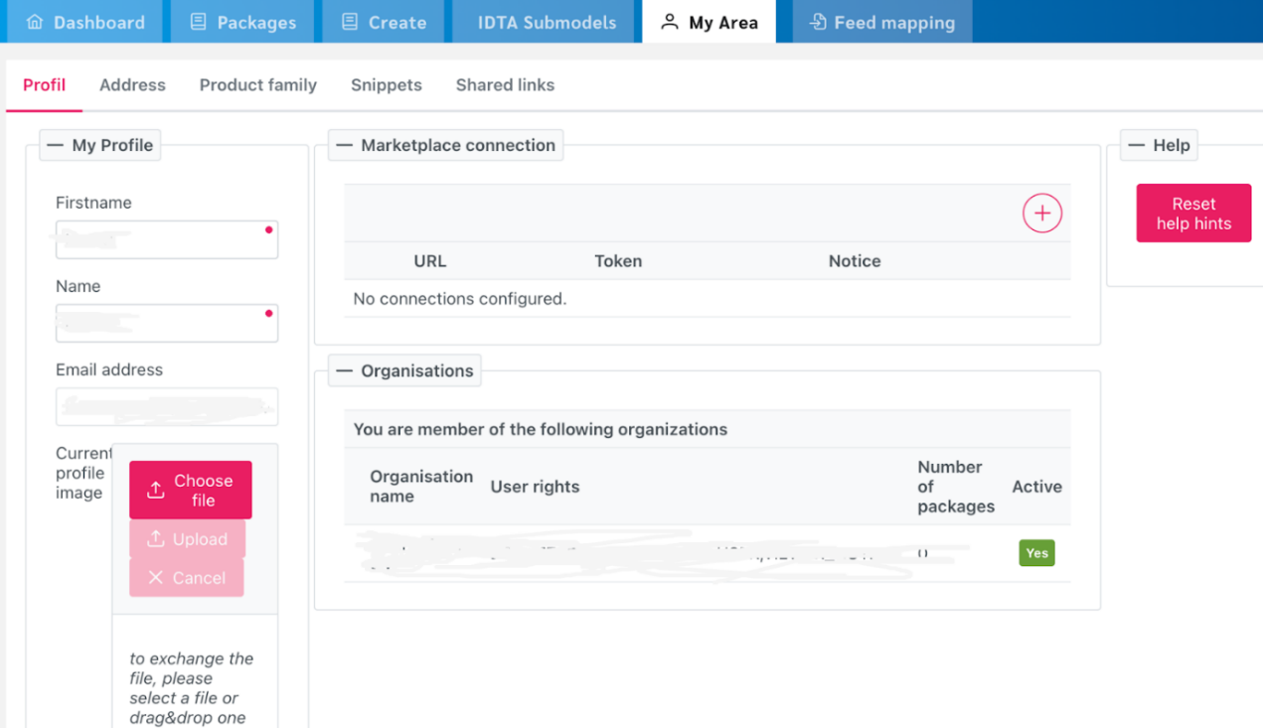

Figure 3‑11: My Area Section in AAS Suite

This section contains your profile details and other personal information:

* Profile: Displays basic user information like First Name, Last Name, Email, and Profile Image (you can update this image by dragging and dropping a new file).
* Address: Allows you to update your address information.
* Product Family: This section may show details about the product families you are involved with.
* Snippet: This is likely where you can add or view small pieces of reusable data.
* Shared Links: Shows any shared links related to your AAS or other content.

## Feed Mapping

The Feed Mapping section helps you manage the details of AAS packages and their associated feed data:

* It lists package details such as:
  + Package ID: A unique identifier for each package.
  + Mapping ID: A specific identifier for the mapping.
  + Kind: The type of mapping
  + Created At: Timestamp of when the package was created.
  + Created By: The user who created the package.
  + Modified At: Timestamp of the last modification.
  + You can view and manage these feed mapping details as part of your AAS creation or modification process.

Each of these sections is designed to help you manage the lifecycle of your Asset Administration Shells, from creation to validation, and ultimately sharing or publishing them for wider use.

# **AAS Server Selection**

As shown in *Figure 4‑1*, the top right side displays a selection list of servers, such as *Internal Infrastructure* and <https://v3.admin-shell-io.com/>. These are the servers accessible by the AAS-Designer. By selecting one, the list of corresponding shells become available for access.

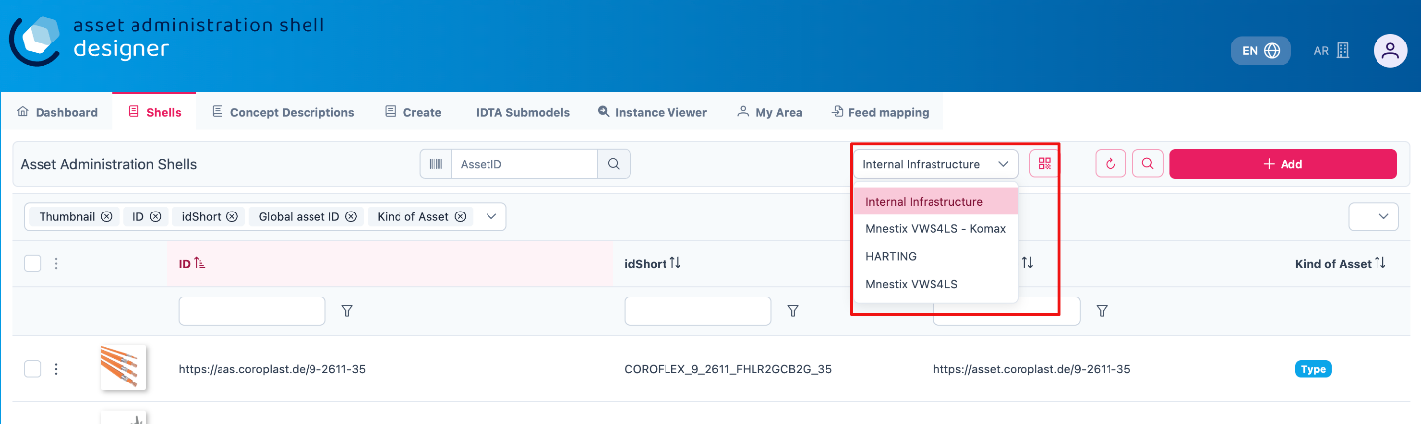

Figure 4‑1: List of shells in other servers

The AAS-Designer’s *Internal Infrastructure* server has its own configurable settings. It provides role-based privileges, ensuring that access is granted according to user roles.

## **For Admin Users**

If you are an **Admin**, follow these steps to view or modify the server configuration:

1. Navigate to **"My Area"** and click on the **organization.**
2. You will see a list of servers along with their status (**Active/Inactive**), as well as their corresponding registries and repositories.

Refer the figure below for a visual representation.

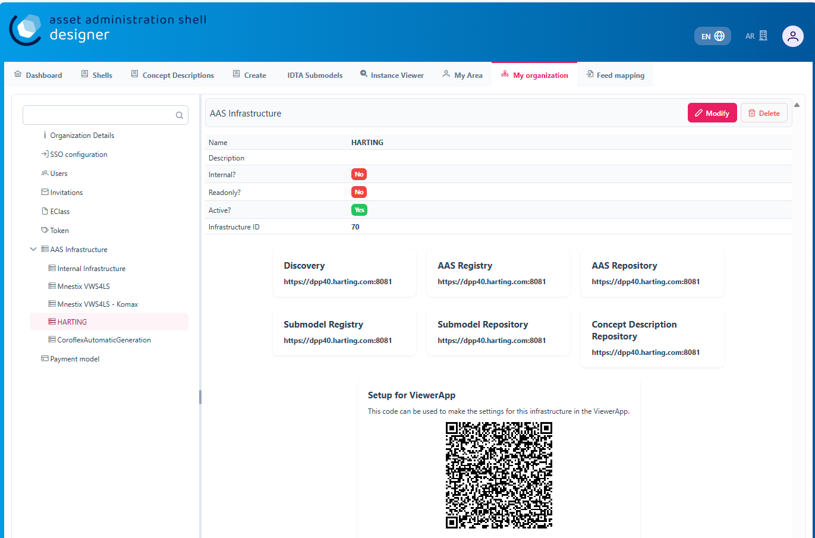

Figure 4‑2: Server Configuration for Admin

## **For Users with Lower Privileges**

If you have a lower authority role and lack the necessary permissions, you will not be able to view the server information, as indicated in below figures.

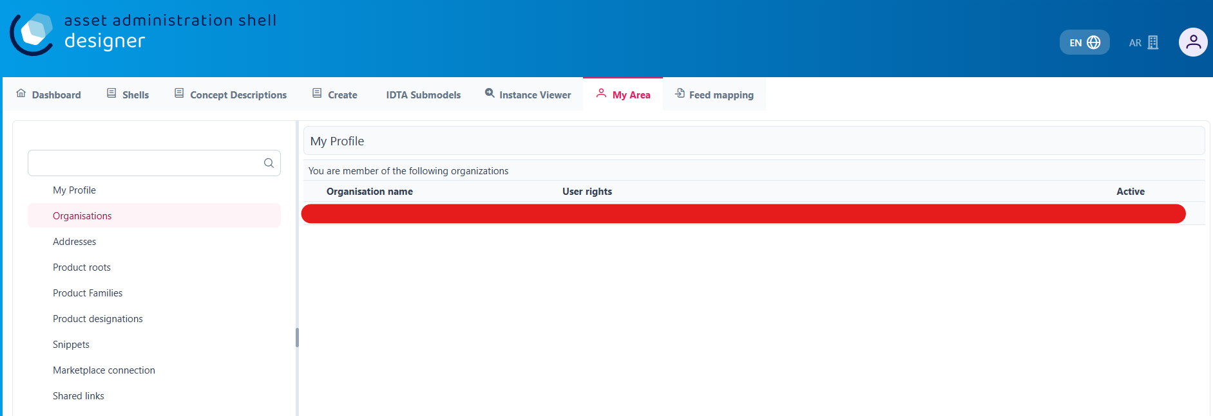

Figure 4‑4: Server Configuration for different Authority Role

# **Operating the Tree Structure**

To view the tree structure of the shell, you need to get into the shell. Follow the following steps to get into/ modify the shell.

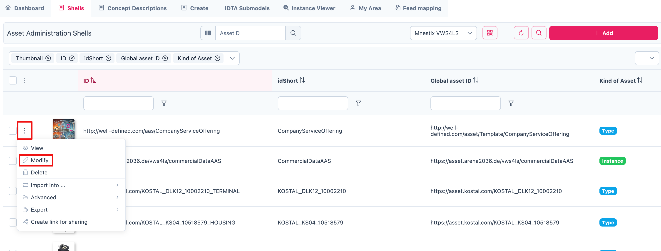

Figure 5‑1: Overview of Shells

To modify a shell, follow these steps:

1. In the Shells Overview, click on the three-dot menu on the left side of the shell.
2. Select "Modify" from the dropdown menu.
3. You will now see the dashboard of the selected shell.

On the left side of the dashboard, you will find the tree structure, which consists of:

* Submodels
* Files
* Concept Descriptions

You can add, modify, or remove any submodel within this tree structure at any time. Refer to the figure below for a visual representation of the tree structure.

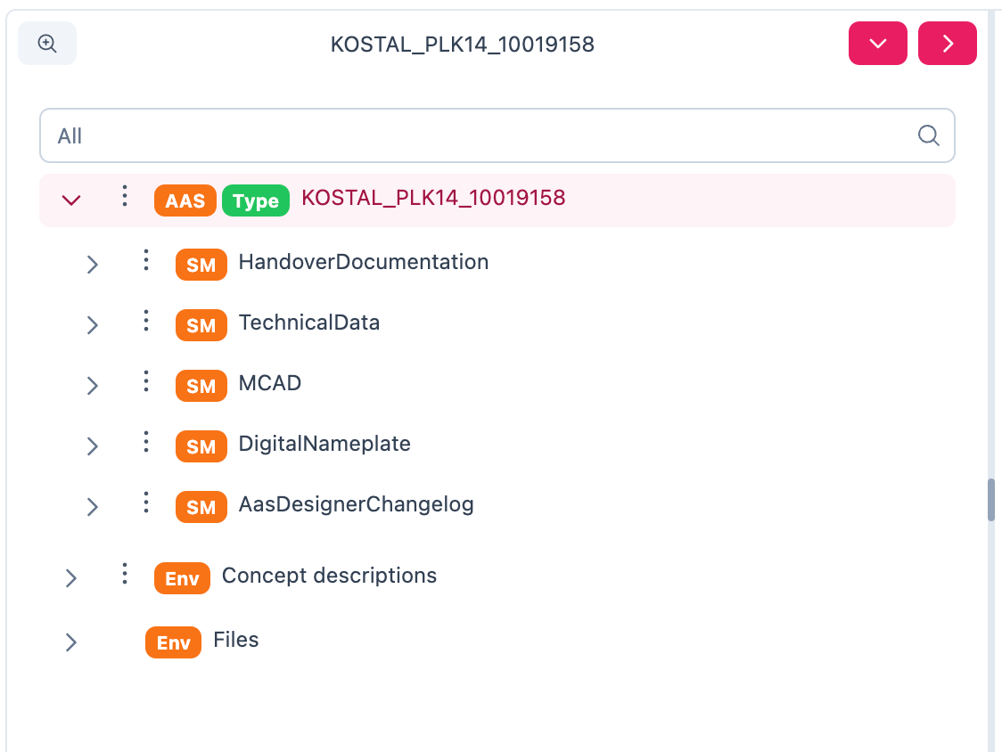

Figure 5‑2:Understanding Tree Structure in AAS Designer

As you click on the arrow to the left of any submodel, such as HandoverDocumentation, a nested structure will expand beneath it. This reveals additional elements contained within the submodel. Referring to the figure below, you will see the corresponding properties of the submodel. These properties can be modified as needed, allowing you to update existing values or add new properties to the submodel.

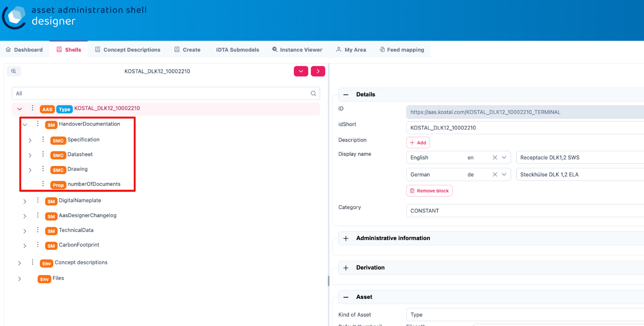

Figure 5‑3: Expanding the Tree Structure in AAS Designer

The AAS Shell of a component follows a structured tree hierarchy, which can be modified by the user based on the available information. For example, in the figure above, [KOSTAL_DLK12_10002210](https://produktkatalog.kostal-kontakt-systeme.com/web/kostal/de/KOSTAL/1544095543984/Steckh%C3%BClse%0ADLK%201%2C2%20ELA/PR/10002210/index.xhtm) represents a component whose AAS needs to be identified. Under this component, there are multiple submodels, such as HandoverDocumentation [1], TechnicalData [2], DigitalNameplate [3], MCAD and AasDesignerChangelog.

Within every tree structure, one will find two common elements: Concept Description and Files. The AAS can define its own dictionary, which contains semantic definitions of its submodel elements. These semantic definitions are known as Concept Descriptions (ConceptDescription). The Files section contains all documents and files uploaded to the AAS Shell of the component, ensuring that relevant information is easily accessible and well-organized.

The AAS Designer presents a tree structure that visually organizes different components of an Asset Administration Shell (AAS). This hierarchical representation includes elements such as Submodels, Properties, Property Values, and Concept Descriptions.

## Inserting elements

For example, in the AAS Designer’s directory tree, you may encounter elements like:

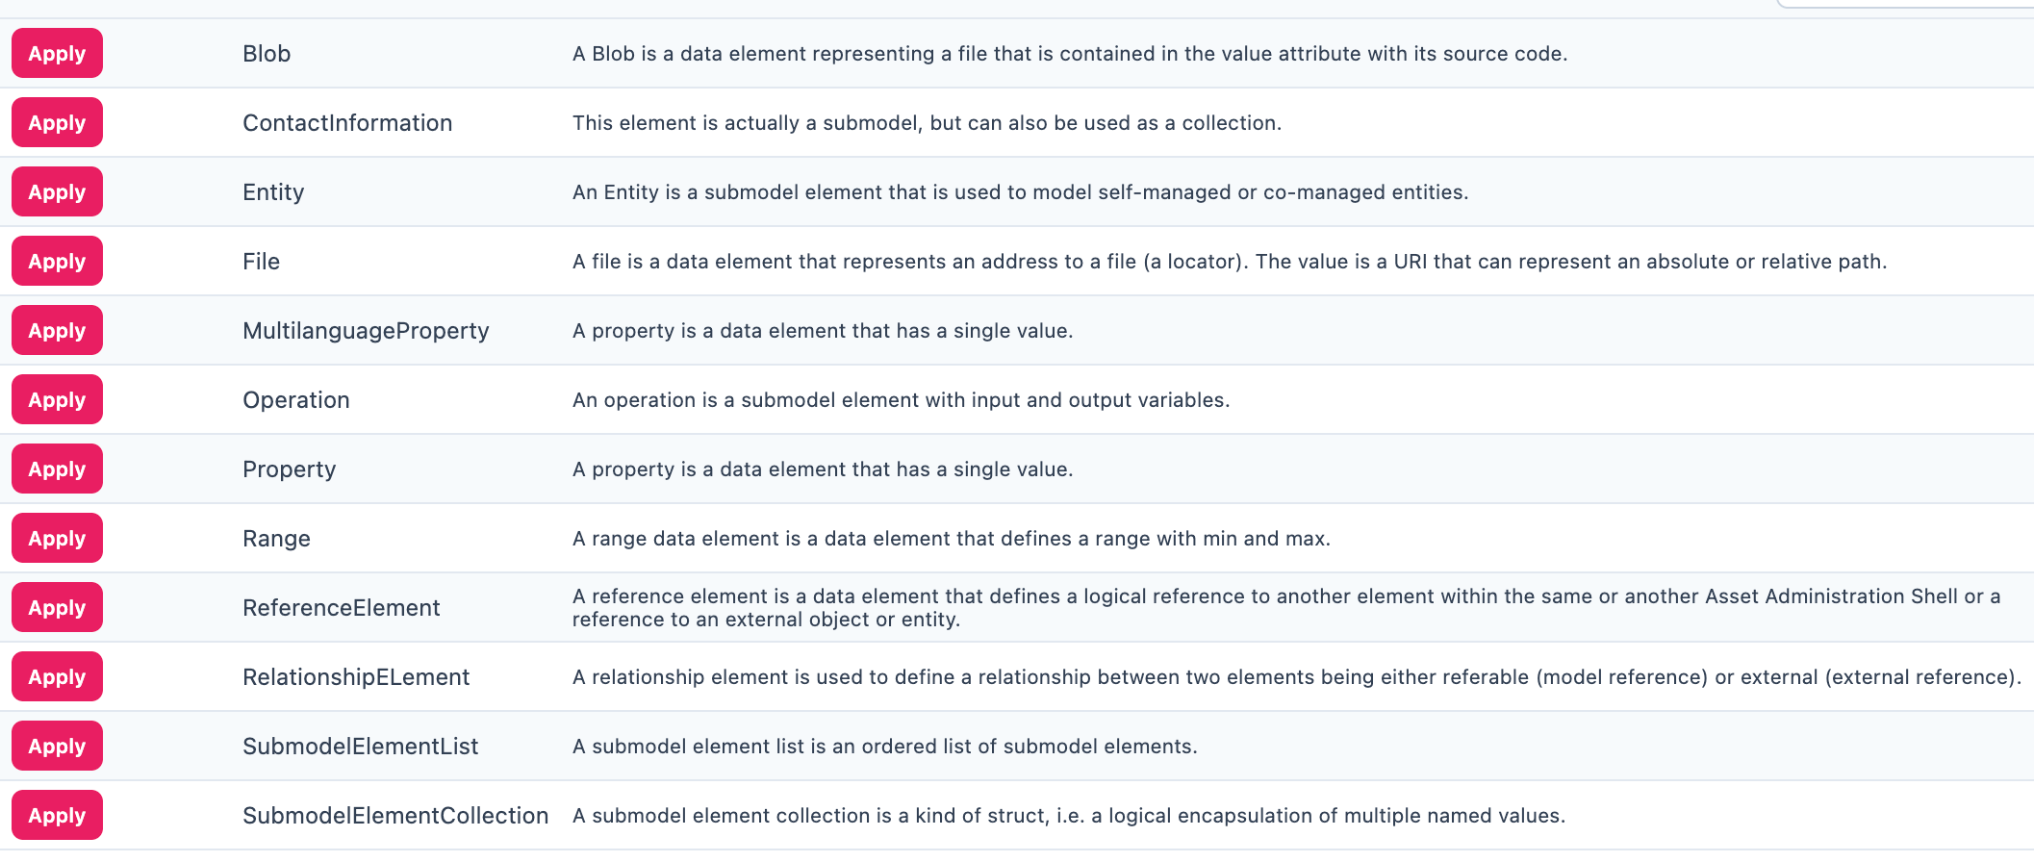

Figure 5‑4: Inserting Elements in the AAS Designer

To get a better view of the elements and their functionality, refer the following table:

|  |  |
| --- | --- |
| **Element Name** | **Description** |
| **Blob** | A data element representing a file that is contained in the value attribute with its source code. |
| **ContactInformation** | This element is actually a submodel, but can also be used as a collection. |
| **Entity** | A submodel element used to model self-managed or co-managed entities. |
| **File** | A data element that represents an address to a file (a locator). The value is a URI that can represent an absolute or relative path. |
| **MultilanguageProperty** | A property data element that has a single value (can support multiple languages). |
| **Operation** | A submodel element with input and output variables. |
| **Property** | A data element that has a single value. |
| **Range** | A data element that defines a range with minimum and maximum values. |
| **ReferenceElement** | A data element that defines a logical reference to another element within the same or another Asset Administration Shell or to an external object/entity. |
| **RelationshipElement** | Used to define a relationship between two elements—either referable (model reference) or external (external reference). |
| **SubmodelElementList** | An ordered list of submodel elements. |
| **SubmodelElementCollection** | A logical encapsulation (struct) of multiple named values. |

Submodels (SM): HandoverDocumentation [1], TechnicalData [2], DigitalNameplate [3], etc.

* Submodel Element Collections (SMC)
* Properties (Prop): specification, data_sheet
* Property Value: It is a reference to the global ID of a coded value. It is unique in nature. Concept Descriptions (CD) are supported, allowing the generation of semantic references that define standardized meanings for properties.
* The value of Property/value must match the referenced coded value in Property/valueId if both a Property/value and a Property/valueId exist.

1. Operating the Elements in AAS

As previously mentioned, there are various types of elements available and selectable based on our requirements in AAS Designer.

This chapter provides definitions for some of the most important elements in AAS.

* Property: A property is a data element that possesses a single value. (For example, properties with specific values such as WireDiameter.)
* Range: A range data element defines a range with a minimum and maximum value. (For example, TemperatureRange.)
* SubmodelElementList: A submodel element list is an ordered list of submodel elements. (TechnicalData, DigitalNameplate.)
* SubmodelElementCollection: A relationship element is utilized to establish a connection between two elements, which can be either referable (model reference) or external (external reference).

To insert a new element, click on the three-dot menu on the left side of the SubModel. From the dropdown menu that appears, select the "Add" option. Then select in the following dropdown menu “Elements”. You will then see a list of all available elements, such as range, property, and more. Now you can choose one element and it will be added to the tree hierarchy.

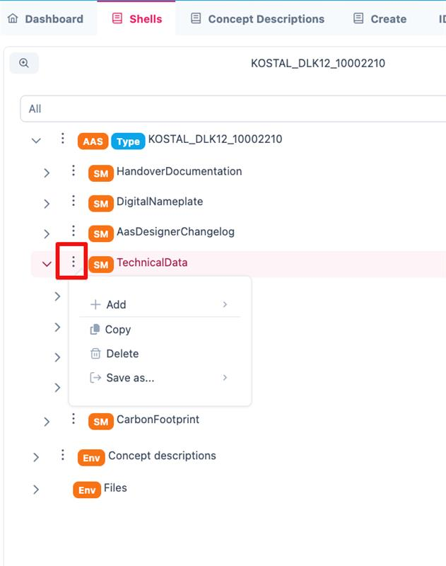

Figure 5‑5: Three dot menu in the tree hierarchy

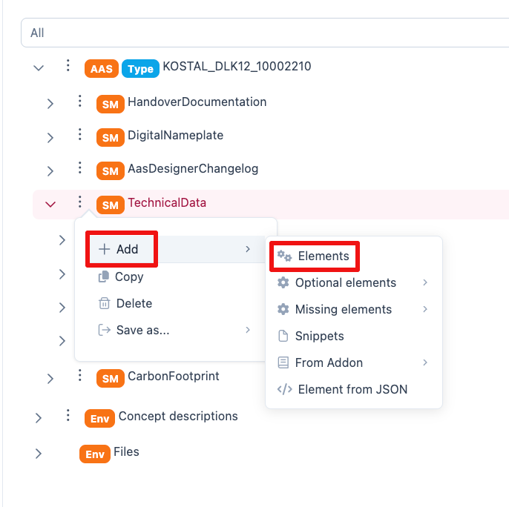

Figure 5‑6: Adding new elements

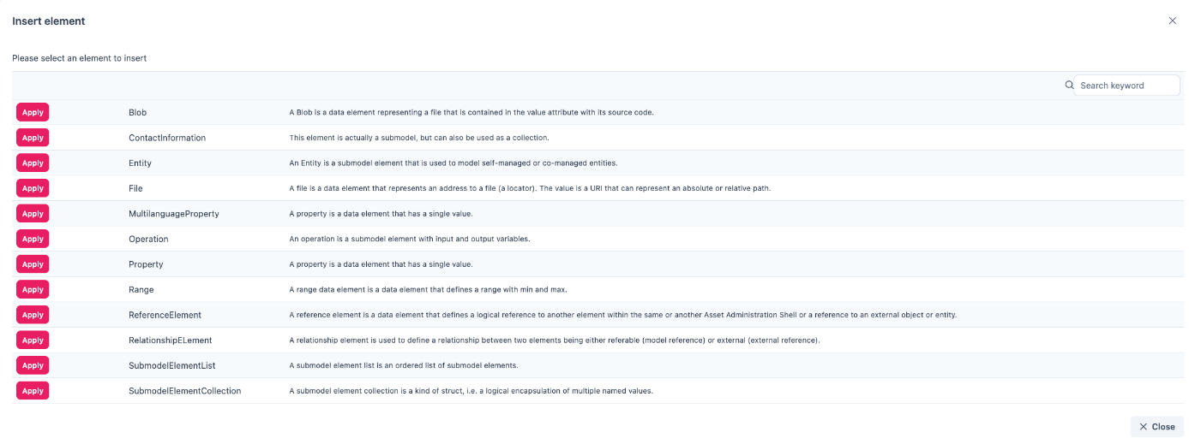

*Figure 5‑7: Options of* *Elements*

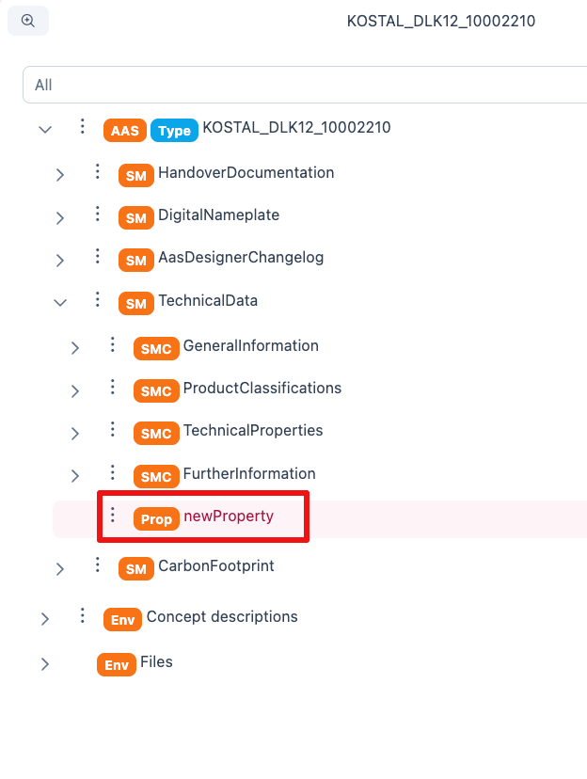

*Figure 5‑8: Adding new Element*

## Property

A property can be defined in detail with semantic reference, unit definition and other value specific definitions (i.e. tolerance range) via Concept Description (CD), Embedded Data Definition (EDD) and Qualifiers.

CD is used to provide a standardized semantic reference for a property, ensuring clarity and interoperability across different systems. It defines the meaning and context of the property within an asset administration shell.

EDD specifies additional characteristics of a property, such as data type, value range, or constraints. It is useful when an external reference is not available or needed for defining detailed attributes.

Qualifiers provide contextual information about a property, such as accuracy, validity period, or measurement conditions. They help refine the meaning and usage of a property without altering its core definition.

As an example in this document, the following JSON example shall be modelled accordingly in the AAS-Designer:

{

"idShort": "overallLength",

"description": [

{

"language": "en",

"text": "Specifies the overall length of the terminal (see diagram \\\"Terminal Dimensions\\\"). Specifies the value of the numerical value and the tolerance range. \\nThe values of the limits of the tolerance, lowerBoundary and upperBoundary, shall be interpreted as \\\"modifiers\\\" to the actual value. To obtain an absolute range of valid values, the values of boundaries shall be added to the actual value, regardless of the Upper or Lower prefix. For example, to define a value of 100mm with a tolerated variation between 14.7mm and 15.3mm, the definition would be Value = 15 mm, LowerBoundary=-0.3, UpperBoundary=+0.3. The Unit of the tolerance boundaries shall always the same as in the defining context."

}

],

"qualifiers": [

{

"kind": "ConceptQualifier",

"type": "lowerBoundary",

"valueType": "xs:double",

"value": "-0.3"

},

{

"kind": "ConceptQualifier",

"type": "lowerBoundary",

"valueType": "xs:double",

"value": "+0.3"

}

],

"embeddedDataSpecifications": [

{

"dataSpecificationContent": {

"preferredName": [

{

"language": "en",

"text": "millimeter"

}

],

"shortName": [

{

"language": "en",

"text": "mm"

}

],

"unit": "Millimetre",

"unitId": {

"type": "ExternalReference",

"referredSemanticId": {

"type": "ExternalReference",

"keys": [

{

"type": "GlobalReference",

"value": "https://cdd.iec.ch/cdd/iec62720/iec62720.nsf/Units/0112-2---62720%23UAB072"

}

]

},

"keys": [

{

"type": "GlobalReference",

"value": "0112/2///62720#UAA862"

}

]

},

"sourceOfDefinition": "https://qudt.org/2.1/vocab/unit#MilliM",

"symbol": "mm",

"dataType": "REAL_MEASURE",

"definition": [

{

"language": "",

"text": "SI base unit ampere divided by the 0.001-fold of the SI base unit metre"

}

],

"modelType": "DataSpecificationIec61360"

},

"dataSpecification": {

"type": "ExternalReference",

"keys": [

{

"type": "GlobalReference",

"value": "http://admin-shell.io/DataSpecificationTemplates/DataSpecificationIEC61360/3/0"

}

]

}

}

],

"valueType": "xs:double",

"value": "15",

"modelType": "Property"

}

### “Details”

The Property definition begins in the “Details” section, where the name of the property is assigned in the *idShort*. In addition, a language-dependent short *description* and a *display name* of the respective property can be described. If present, please make sure that at least an english version is present. In the datatype section, NULL or CONSTANT is usually specified for type definitions.

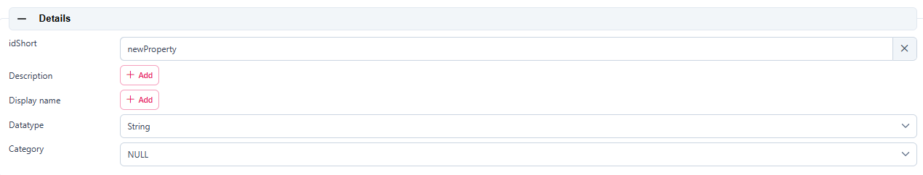

*Figure 5‑9: Details section area*

### “Content”

In the “Content” section a nominal value can be assigned. If available, *valueId* can be filled in with a semantic reference to a value definition (typically a IRDI or IRI).

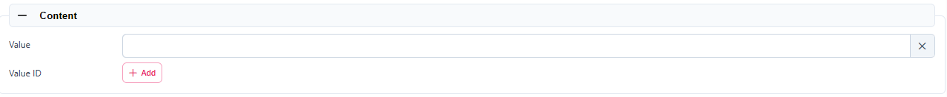

*Figure 5‑10: Content section area*

### “Semantic Description”

Next up the Semantic description can be added. It must be noted that this lead to the creation of a so called “Concept Description” (CD).

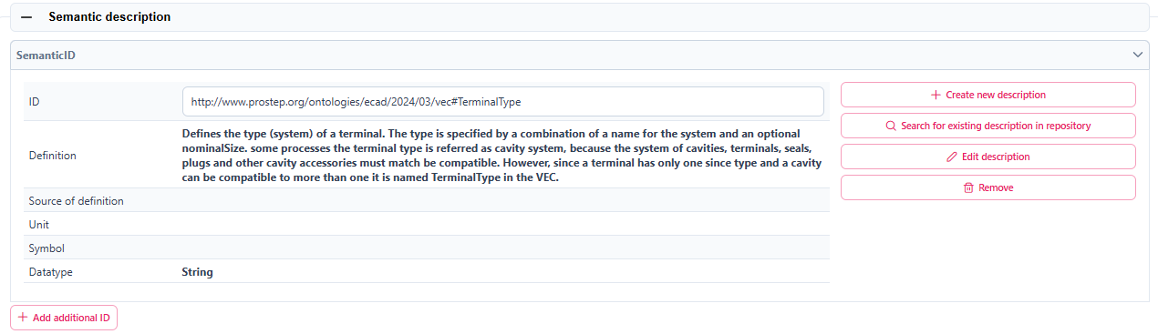

*Figure 5‑11: Semantic description area*

This contrasts with the “Qualifiers” and “Data Definitions”, which are directly embedded in the property definition.

### “Qualifier”

Additional definitions for a property can be done via the “Qualifier” concept, i.e. definition of Upper- and Lower-Boundaries as shown below:

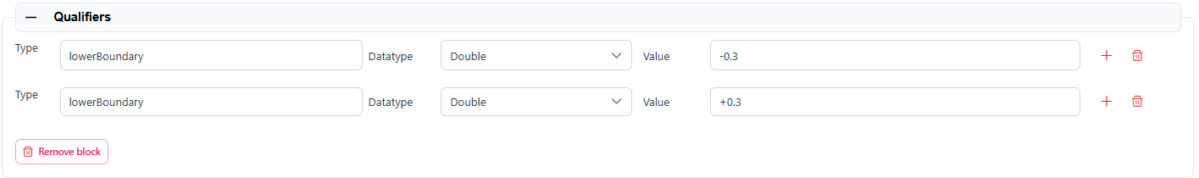

*Figure 5‑12: Qualifier area*

Qualifiers in Asset Administration Shell (AAS) provide additional metadata about elements, acting as type-value pairs that define properties related to value, semantics, or existence.

### “Data Definition”

Arbitrary embedded data definitions can be added that use exactly the same IEC61360 data structure as used for Concept Descriptions. and was initially designed to describe an IEC-CDD reference. But it can also be used for referencing other systems or definition purposes, such as to define a unit definition and/or a range of preset values (enums).

A typical usage would be for an embedded unit definition can be done as shown below.

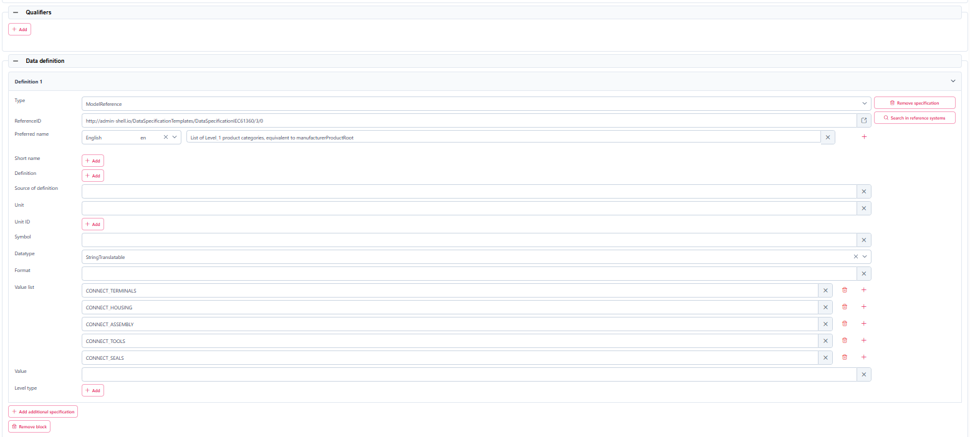

*Figure 5‑13: Data definition area*

The embedded data definitions use exactly the same IEC61360 data structure as used for Concept Descriptions and was initially designed to describe an IEC-CDD reference. But it can also be used for referencing other systems or definition purposes, such as to define a range of preset values (enums).

A typical usage would be for an embedded unit definition can be done as shown below.

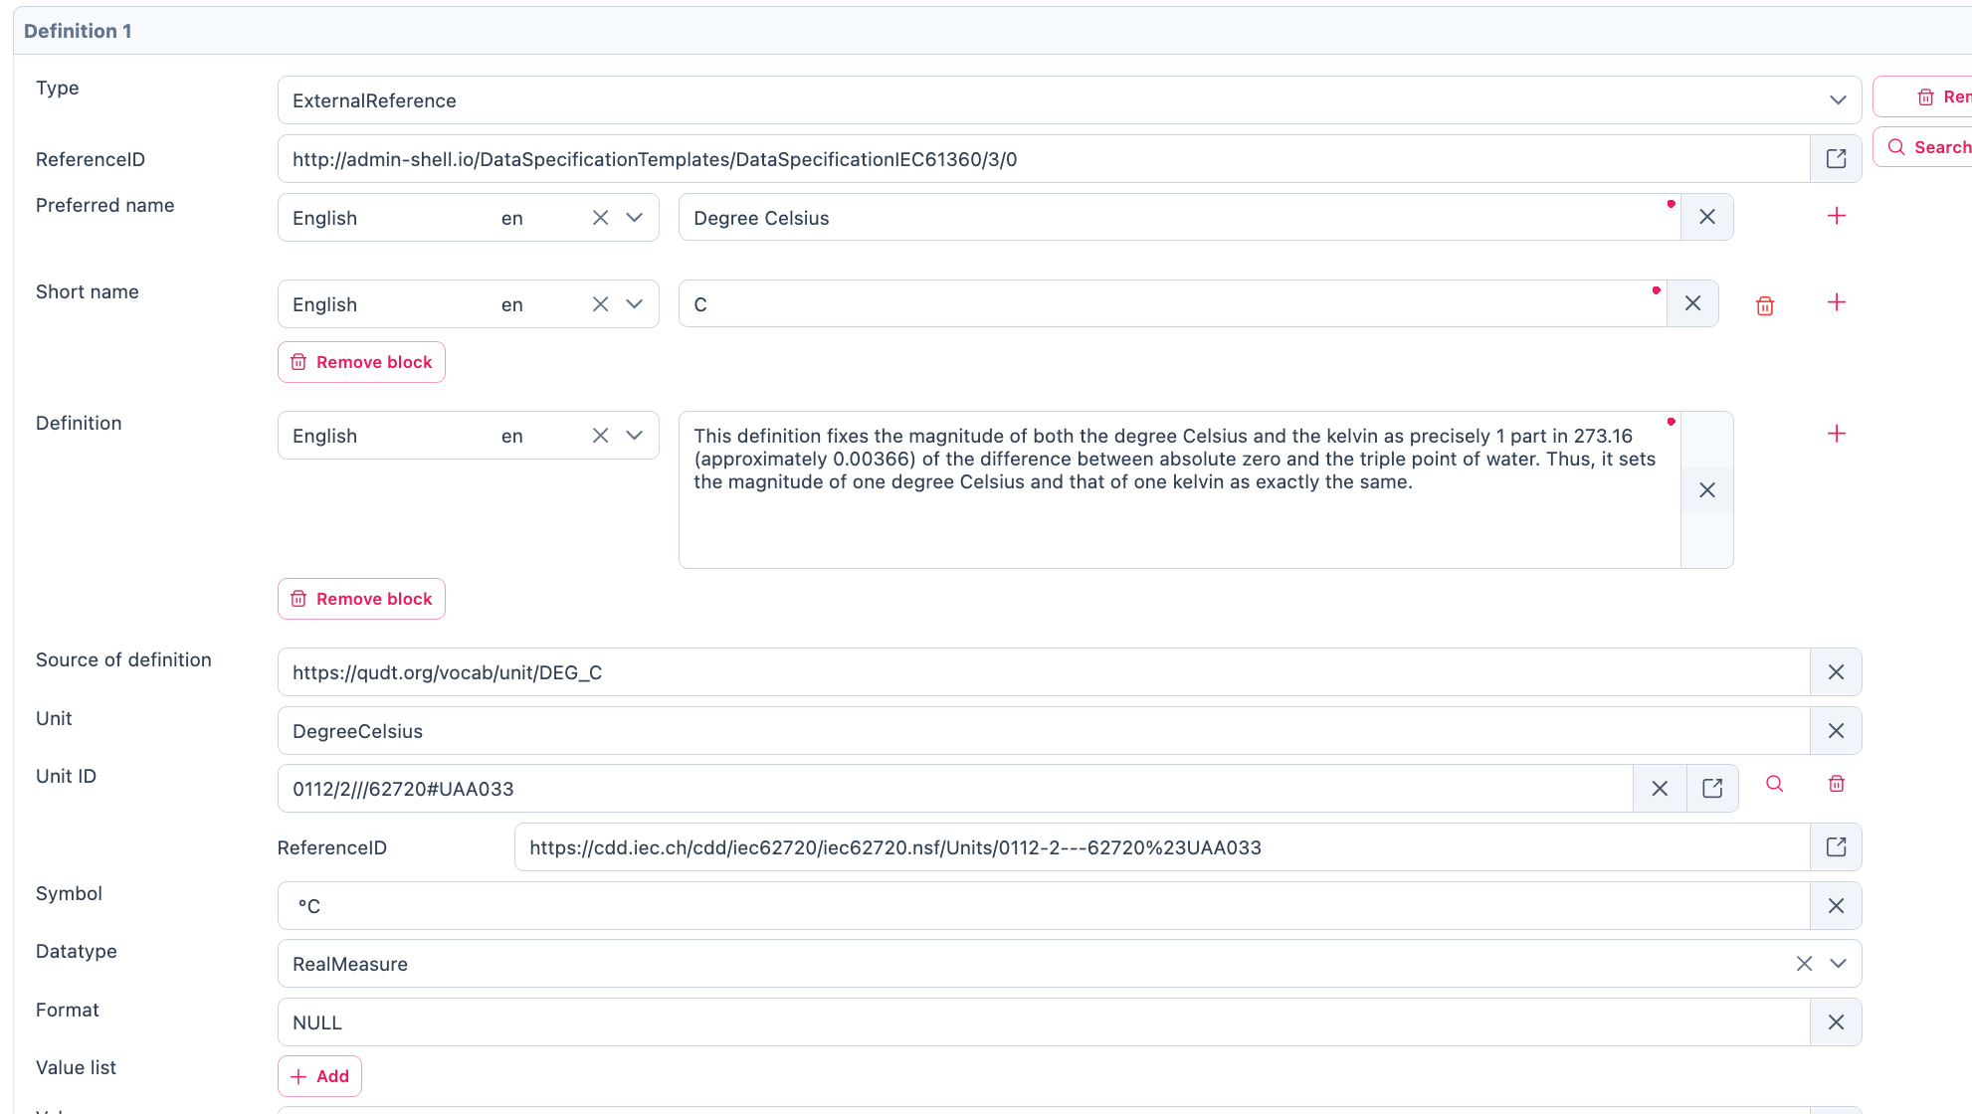

*Figure 5‑14: Example of a filled in Data definition*

In the beginning of the Data definition, you can choose between the Type ModelReference and ExternalReference. A ReferenceID can be included in the following. In the Data definition you can assign a Preference name in different languages. You can give the definition a name in the “Preferred Name” Section. To shorten it up you can give the Preferred Name in “Short Name”. In the Definition Section you can describe it in a short sentence. To give a reference for the definition you can fill in the “Source of Definition”. The most important feature in the Data definition is the Value List. In the Value List you can Insert a List of entities pertaining to the selected element.

## Range

In the following all the important definitions will be explained which are necessary for a Range. The only difference compared to Property is the area of Content.

In the “Content” part you can now select Datatype from a dropdown List, which will open up when you click on the bar at the Datatype. You can also define an Range from Minimum and Maximum.

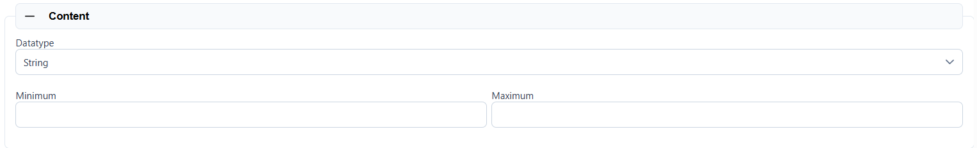

*Figure 5‑15: Content part of Range*

## SubmodelElementList

This section will explain how to insert a SubmodelElementList and which features it contains. A SubmodelElementList is a structural element in the Asset Administration Shell (AAS) that organizes multiple submodel elements in a structured and ordered manner. It is particularly useful for handling sets, lists, arrays, and ordered collections of elements with the same semantic meaning.

Unlike a SubmodelElementCollection, which allows heterogeneous elements, a SubmodelElementList enforces semantic and type consistency among its elements.

Common use cases include:

* Representing multi-dimensional arrays (e.g., a 2D table of values).
* Storing repeated elements that follow a predefined format (e.g., lists of technical specifications).
* Grouping structured information, such as a series of sensor readings over time​.

The SubmodelElementList inherits the basic definition structure from Property, including idShort, description, and display name. It includes a specific attribute called ‘Order Relevant’ which Indicates whether the order of elements in the list is semantically meaningful.

The semantic description of a SubmodelElementList is defined using Concept Descriptions (CDs), as outlined in the Property section.

The Qualifier of SubmodelElementList is defined using Qualifer *under* ***Property*** *for how constraints (e.g., upper/lower bounds) can be applied to list elements.*

The Data Definition of SubmodelElementList is defined using Data Definition as outlined in the Property section.

## SubmodelElementCollection

In the following all the important definitions will be explained which are necessary for a *SubmodellElementCollection*. A *SubmodelElementCollection* (SMC) is a structural element used within the Asset Administration Shell (AAS) to organize and manage multiple related *SubmodelElements*. Unlike a *SubmodelElementList*, which primarily deals with ordered and homogeneous elements, a *SubmodelElementCollection* serves as a container for heterogeneous elements with a predefined semantic structure. It is particularly useful when defining complex assets that consist of multiple distinct properties grouped under a common semantic meaning. Each property within the collection should have a clearly defined semantic representation, referenced by its *semanticId*​.

For example, a document may have properties such as *title*, *version*, *author*, and *date*, all of which belong together. A single document is therefore represented as a *SubmodelElementCollection*. If there are multiple documents, they may be stored in a *SubmodelElementList* containing multiple *SubmodelElementCollections*​.

A *SubModellCollection* is used for a kind of structure which includes the connection of multiple named values. The elements which you can fill in in the *SubmodellElementCollection* are the same as explained in the Property Topic. The only difference is the Content part. In the Content Part you will See a listing of the Values which are created in the *SubModelList*. In the following picture is an example for how the listing will look like. It allows for organizing related elements into a logical collection while maintaining their individual properties and semantics.

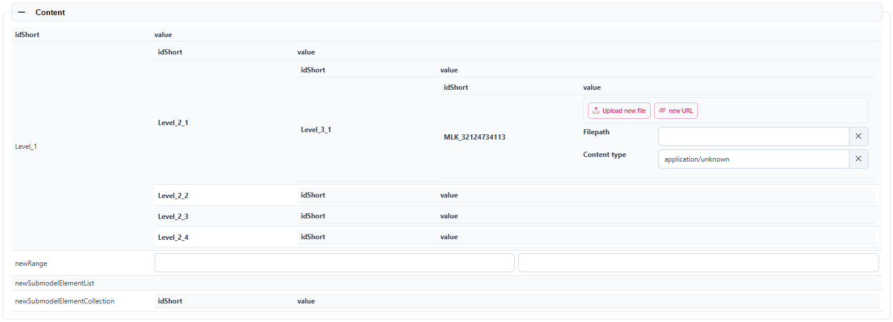

*Figure 5‑16: Example of a listing in the Content part*

*SubmodelElementCollection* follows the same structural definition as Property for *idShort*, description, and display name. It also includes ‘Category’, which indicates whether the collection represents static parameters or runtime variables.

A *SubmodelElementCollection* refers to Concept Descriptions (CDs) for semantic meaning, consistent with the approach used for Properties.

As described under Property, qualifiers add metadata. Within *SubmodelElementCollections*, specific qualifiers like **Cardinality** or **Custom Types** (Type, Datatype, Value) define collection-specific constraints.

Qualifiers allow additional contextual constraints and metadata for elements within a *SubmodelElementCollection*.

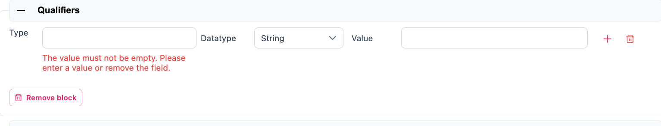*Figure 5‑17: Custom Qualifier of SubmodelElementCollection*

### Custom Qualifiers

1. Type: Defines the specific context of the qualifier.
2. Datatype: Specifies the expected format of the qualifier value.
3. Value: Represents the actual qualifier value.

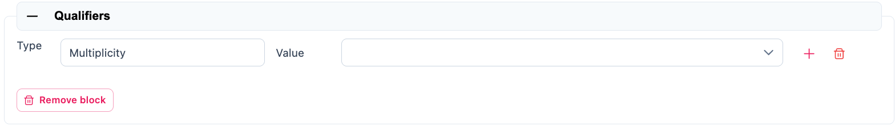*Figure 5‑18: Cardinality Qualifier of SubmodelElementCollection*

### Cardinality

1. Type: Specifies how many elements the collection can contain. Eg. Multiplicity
2. Value: Specifies cardinality constraints. Example: "0..1" (optional element), "1..*" (mandatory and multiple elements).

The Data Definition of *SubmodelElementCollection* is defined using Data Definition as outlined in the Property section.

# **Handling AAS Shells**

In the AAS Designer, *Shells* represents a list of individual Asset Administration Shells (AAS), which serve as digital representations of physical or virtual assets. Each Shell contains structured information about a specific asset, including its metadata, submodels, and associated files.

Within the Shells section of the AAS Designer, users can:

* View and manage all created AAS instances.
* Edit and modify existing shells based on updated information.
* Validate AAS structures to ensure compliance with industry standards.
* Share AAS within their organization or publish them on the AAS Marketplace.

Each AAS Shell consists of submodels, such as Technical Data, Digital Nameplate, Handover Documentation, and more, allowing for a modular and flexible approach to structuring asset-related data.

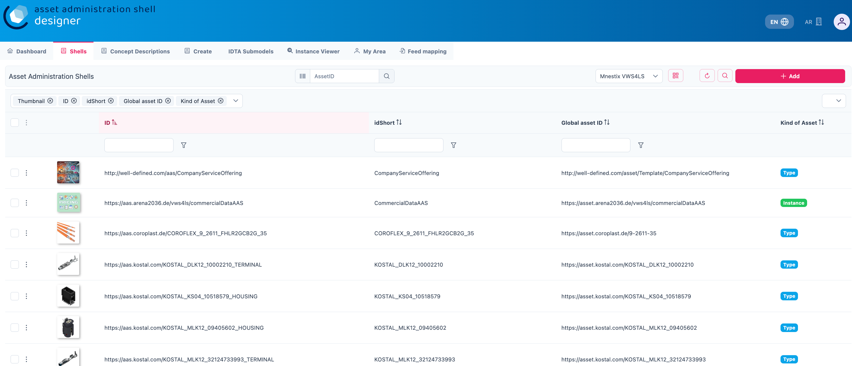

Figure 6‑1: Managing Asset Administration Shells (AAS) in AAS Suite

You will find a list of all AAS components after clicking the *Shells* tab, as shown in the figure above. This section allows you to perform various functions, including:

1. View all existing AAS shells associated with different components.
2. Search and filter shells based on specific criteria.
3. Edit or update existing shells with new information.
4. Validate the structure of an AAS to ensure compliance with standards.
5. Share or publish shells within your organization or on the AAS Marketplace.

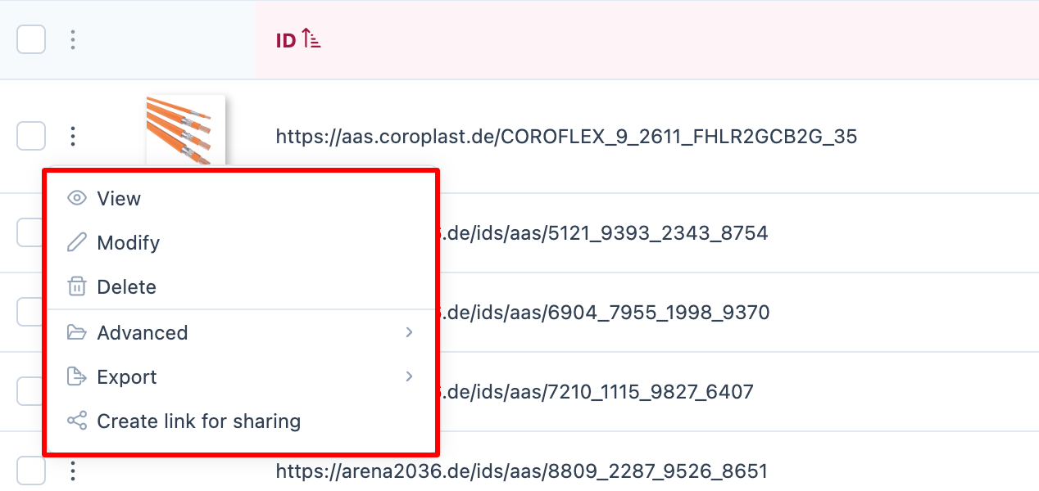

Figure 6‑2: AAS Shell Management Options

If you click on the three dots on the left side of an AAS component, you will find several options such as View, Modify, Delete, Advanced, Export, and Create Link for sharing. Let’s explore each of these options one by one:

## View

The View functionality allows you to see the overall details of the AAS Shell. On the left side, you will find an overview of the component, while on the right side, you can view additional information such as product details, manufacturer details, and other relevant data associated with the component. This gives you a complete picture of the asset and its metadata in a structured and easy-to-navigate format.

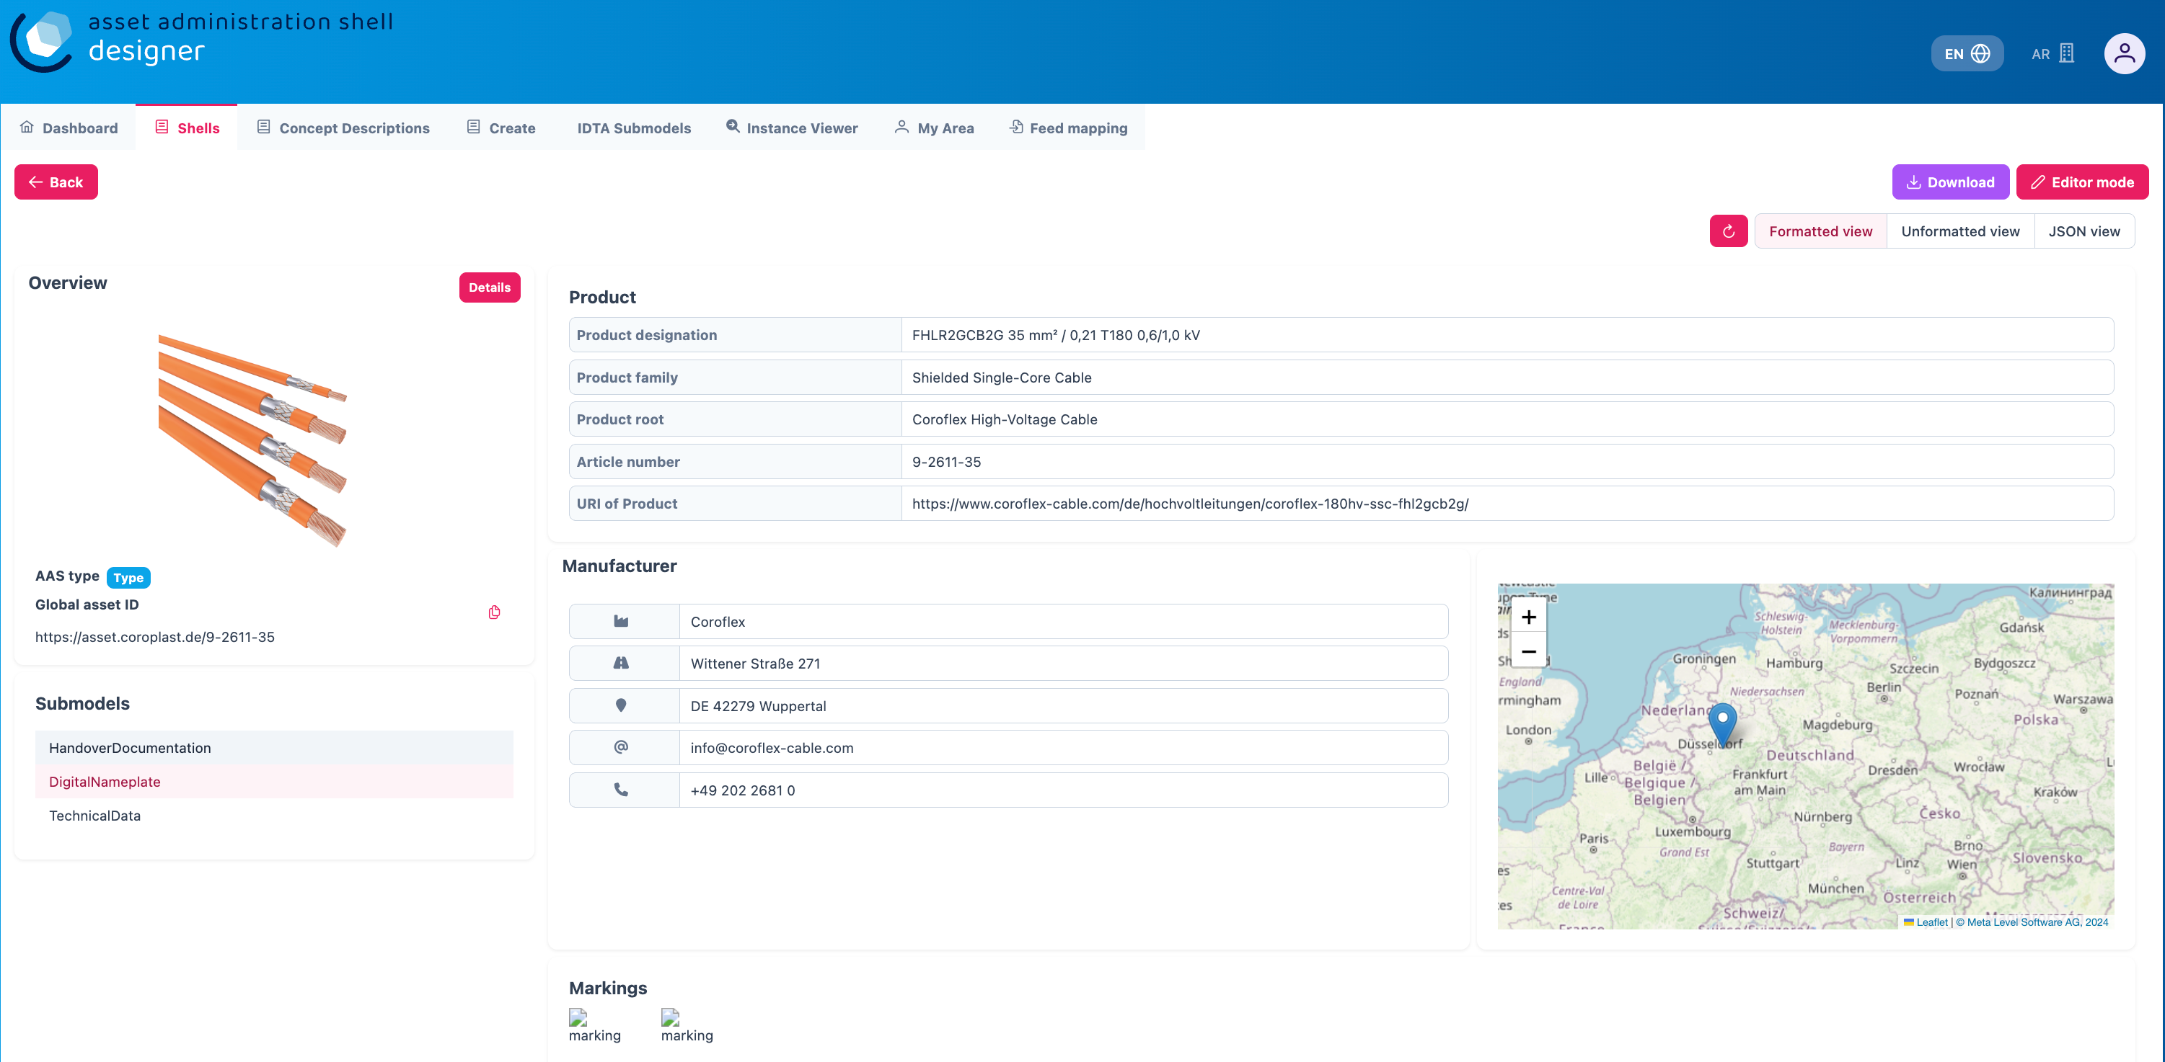

Figure 6‑3: Viewing Detailed Information of an AAS Shell

One can view various details of the submodels by clicking on each of them. In the figure above, you can notice submodels such as *HandoverDocumentation*, *DigitalNameplate*, and *TechnicalData* listed on the left side. When you select any of these submodels, you will be able to explore their specific details.

Additionally, there is an option to view the data added to the AAS in different formats:

* Formatted View: A user-friendly, structured view for easy reading and understanding of the data.
* Unformatted View: A simpler, raw view of the data without any layout or styling.
* JSON View: A machine-readable format, showing the data in JSON (JavaScript Object Notation), which is commonly used for data exchange.

This flexibility allows users to choose the most suitable format depending on their requirements.

## Modify

Modify is the section where you can add, create, update, and delete the component data. You can perform various operations on submodels, properties, and property values, allowing you to modify the AAS shell as needed. Additionally, you have the option to upload media, such as files, wherever applicable within the submodels.

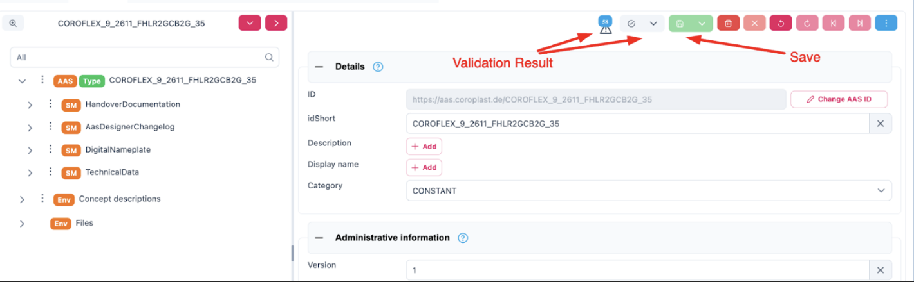

Figure 6‑4: Modifying an AAS Shell in AAS Designer

Once the necessary changes were made, one can save them by clicking the green button at the top right corner of the page. After saving, you can validate any errors by clicking on the grey section shown in the figure, which will highlight any issues or inconsistencies that need to be addressed. This validation process ensures that your AAS remains accurate and compliant with standards.

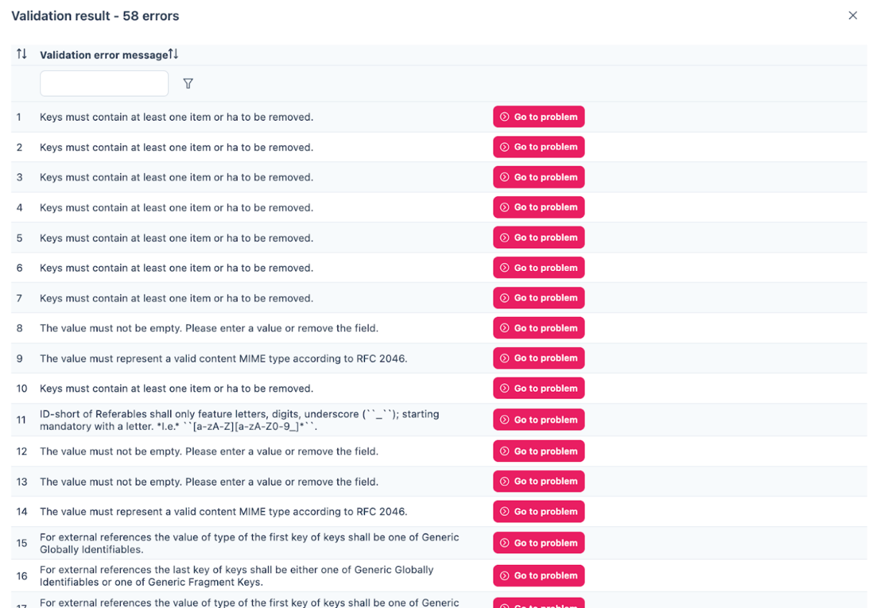

Figure 6‑5: Validation Errors in AAS Designer

As you can see in the figure, the validation errors display a list of all the issues within the AAS shell. Each error will be clearly identified, allowing you to navigate directly to the problem area.

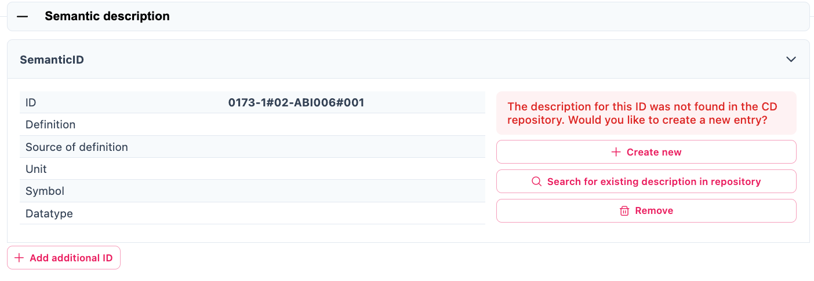

Figure 6‑6: Resolving Validation Errors in AAS Designer

Once you reach the issue, you can make the necessary adjustments to resolve the error. The Designer guides you to the problem once you click the button. This process ensures that your AAS shell is free from issues and fully compliant with the required standards before finalizing or sharing it.

## Delete

The Delete command allows you to remove the AAS shell from the system. When you use this option, the selected AAS shell and all its associated data will be permanently deleted. Make sure to double-check before confirming the deletion, as this action cannot be undone.

## Advanced

There are 2 Advanced Options you can choose from *Create Feed Mapping* and *Duplicate*.

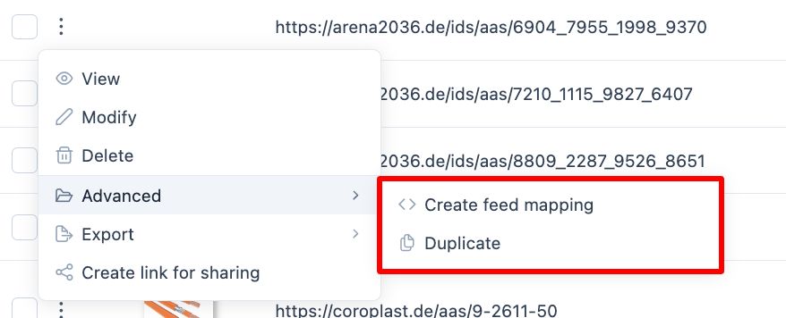

Figure 6‑7: Advanced Options in AAS Designer

### Create Feed Mapping

Feed Mapping allows you to map data fields from an external source (such as a CSV file or JSON data) to the corresponding fields in the AAS Shell. This helps in integrating and synchronizing data from external systems into the AAS.

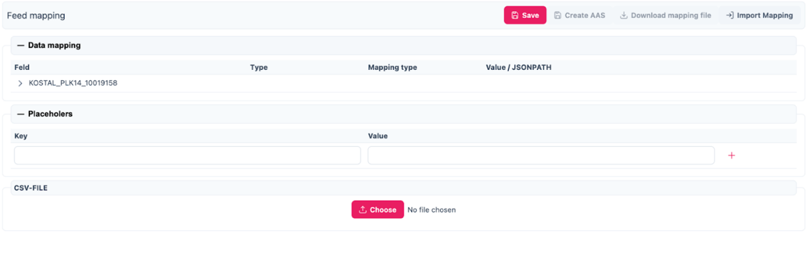

Figure 6‑8: Creating Feed Mapping in AAS Designer

The structure typically includes the following fields:

* Field: The name of the field or attribute within the AAS that is being mapped (e.g., KOSTAL_MLK12_32140734113).
* Type: The type of data expected (e.g., String, Integer, etc.).
* Mapping Type: This defines how the mapping is performed, such as whether it’s a direct Key-Value mapping, or if it follows a specific JSONPath to extract values.

Value / JSONPath: The value or path from the external data source that will be mapped to the field in the AAS (e.g., CSV-FILE or a No file chosen indicator for file upload).

### Duplicate

Duplicate helps to duplicate the entire AAS File.

## Exports

The file can be downloaded in your system in .aasx or .json format.

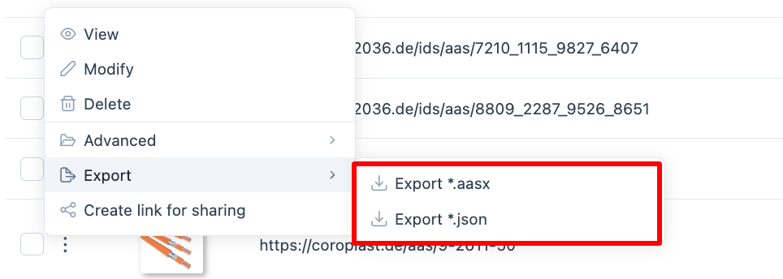

Figure 6‑9: Exporting AAS Data in AAS Designer

## Create Link for Sharing

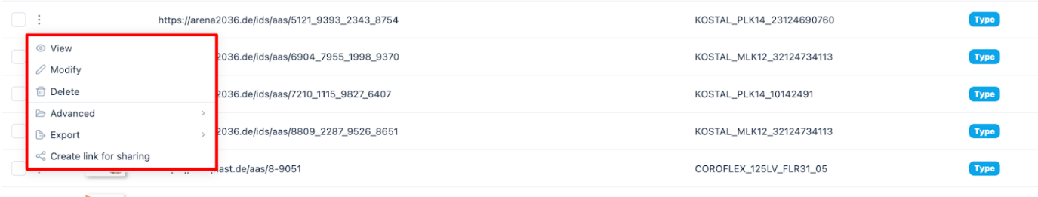

Figure 6‑10: Creating a Shareable Link in AAS Designer

You can create and share an AAS link with others, allowing them to perform CRUD operations (Create, Read, Update, Delete) on the AAS Shell. This link can be used to provide access to a publicly available viewer for the asset administration shell.

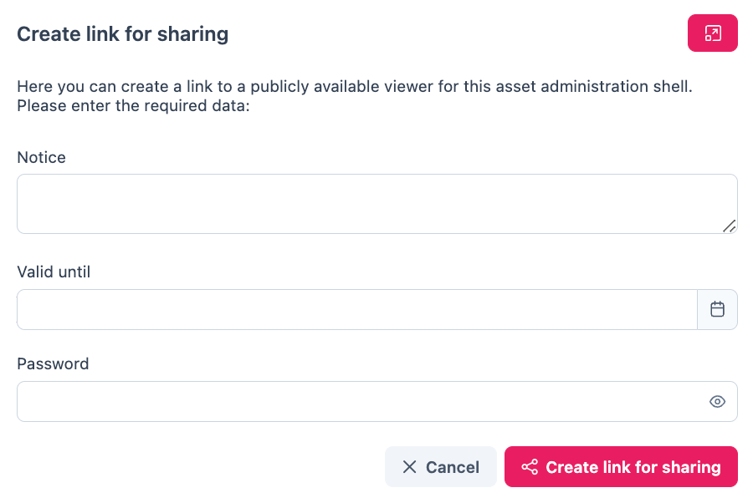

Figure 6‑11: Configuring a Shareabale Link in AAS Designer

To create the link:

1. Write a message: You can include a custom message to provide context or instructions for the recipient.
2. Set validity: Specify the validity period for the link, such as an expiration date, to control access over time.
3. Add a password: For security, you can set a password that will be required to access the AAS Shell via the link.

Once the link is generated, you can copy and share it with anyone who needs access. This feature allows secure and controlled sharing of AAS shells with team members, collaborators, or stakeholders.

# Identification Schemas **and their Importance**

Unique identifiers are required for referencing both an AAS and its Submodels. Unique identifiers are also used to reference external semantic information. The ID schemes described in the following are relevant for the AAS concept.

## UUID/GUID

**UUID** stands for Universally Unique Identifier[1]. It is a 128-bit (16-byte) identifier standardized by the Open Systems Interconnection (OSI) framework and detailed in the RFC 4122 specification. The goal is to generate IDs that are unique across time and space—without needing a central authority to coordinate them. Their uniqueness relies on probability (for V4) or careful design (for V1, V3, V5), making collisions astronomically unlikely—think 1 in 2^122 for random UUIDs.

**GUID** stands for Globally Unique Identifier and is Microsoft’s term, while it is functionally equivalent to a UUID.

**Format**: A UUID is typically written as a 36-character string in hexadecimal, split into five groups by hyphens: 8-4-4-4-12. For example:

550e8400-e29b-41d4-a716-446655440000

That’s 32 hex digits (representing 128 bits) plus 4 hyphens.

**Structure**: Internally, it’s 16 bytes, often broken down into fields like time, clock sequence, and node ID, depending on the version (more on that soon).

**Variants**: RFC 4122 defines a specific “variant” (bits 64-65 set to 10) to distinguish it from other 128-bit ID schemes. Most UUIDs you encounter follow this.

UUIDs are often generated by AAS-Tools to be used in the AAS- and Submodel-IDs. This might be appropriate in many cases for Instance-AAS, but can become problematic for Type-AAS. Therefore, AAS publishers should make a careful decision regarding the usage of UUIDs.

## IRDI (ISO 29005-5)

The International Registration Data Identifier (IRDI) is a global identification system for properties, values, and concepts. It is defined by ISO 29005-5 and ISO/IEC 11179-6 as an established means to create manageable unique identifiers that remain consistent across different languages and IT systems. IRDIs are used in ECLASS, IEC, and ISO standards.

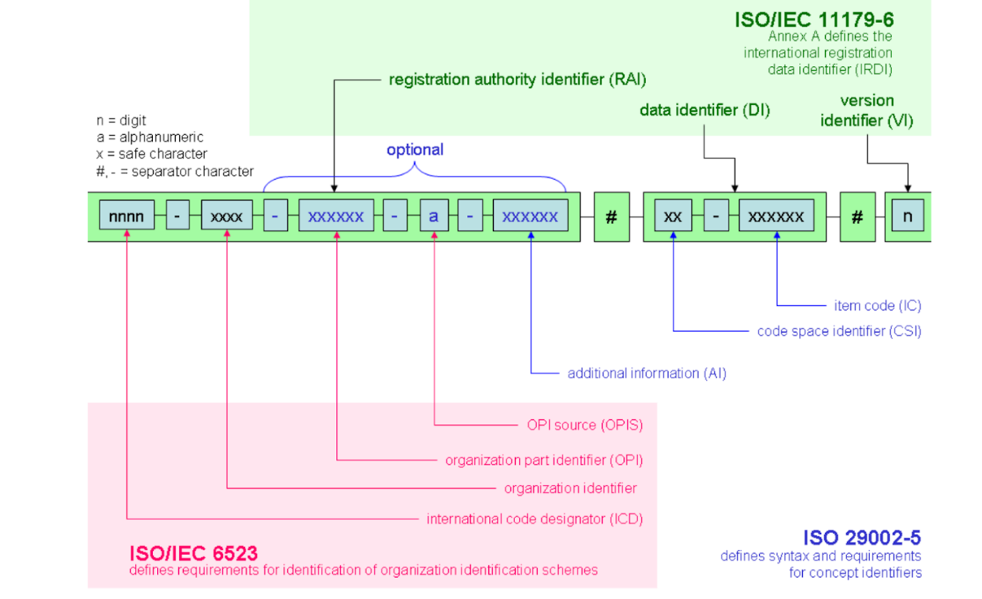

Figure 7‑1: Identification Schema According to ISO 29005-5[2][3]

IRDIs are a historically established referencing mechanism that must be dealt with in the AAS. However, as they require external management, it is not recommended to specify new IRDIs for elements in the AAS.

### Understand the IEC IRDI Structure

An IEC-CDD follows this general format: **ICD**/**OI**/**AI**#**IC**#**VI**

* **ICD (International Code Designator)**: Identifies the registration authority (e.g., "0112" for IEC).
* **OI (Organization Identifier)**: Specifies the organization within the authority (e.g., "2" for IEC).
* **AI (Application Identifier)**: Indicates the specific dictionary or standard (e.g., "61360_4" for IEC 61360-4 DB).
* **IC (Item Code)**: A unique code for the item within the dictionary (e.g., "AAB123").
* **VI (Version Identifier)**: Denotes the version of the item (e.g., "001").

Example: 0112/2///61360_4#AAB123#001

|  |  |
| --- | --- |
| 0112/2///61360_4#AAA032 | |
| **Code:** | **description** |
| 0112/2/ | Issuing Agency Code (IEC) |
| 61360_4 | IEC 61360 Standard Reference |
| #AAA032 | Unique identifier for a property/class |

Table 3 Breakdown of IRDI Example (0112/2///61360_4#AAA032)

### Understand the ECLASS IRDI Structure

An ECLASS IRDI typically follows this format: **ICD**/**OI**/**CSI**#**Code**#**Version**

* **ICD (International Code Designator)**: A code for the registration authority, e.g., "0173" for ECLASS.
* **OI (Organization Identifier)**: Identifies the organization, often omitted or left empty in ECLASS as it’s implicit.
* **CSI (Code Space Identifier)**: Indicates the type of structural element (e.g., "01" for classification class, "02" for property, "07" for value).
* **Code**: A unique identifier for the specific item (e.g., "27-22-01-01" for a class or "AAB123" for a property).
* **Version**: A version number (e.g., "001").

Example: 0173-1#01-27-22-01-01#001 (a classification class in ECLASS)

|  |  |
| --- | --- |
| 0173-1#01-AAA123#001 | |
| **Code:** | **description** |
| 0173 | ICD code for eCl@ss |
| 1 | eCl@ss Office |
| 01 | class |
| AAA123 | identifier of class |
| 001 | version of class |

Table 2 Breakdown of IRDI Example (0173-1#01-AAA123#001)

## URI/IRI

An **URI** (Uniform Resource Identifier) is a string of characters that identifies a resource, standardized by RFC 3986. It is a concept encompassing anything that can be named or located, whether it’s a webpage, a file, or an abstract entity.

**Example**: http://example.com/resource/123.

**Components**: *Scheme* (http), *authority* (example.com), *path* (/resource/123), and optionally *query* (?key=value) or *fragment* (#section1).

**Subtypes**: Includes URLs (locators, like http://example.com) and URNs (names, like urn:isbn:0451450523).

An **IRI** (Internationalized Resource Identifier) is an extension of URI, defined by RFC 3987, that supports non-ASCII characters (e.g., accents, Chinese characters) for global accessibility. IRIs are technically a superset of URIs, thus every URI is an IRI, but not vice versa.

**Example**: <http://exâmple.com/资源/123> encoded by

<https://xn--exmple-xta.com/%E8%B5%84%E6%BA%90/123>.

The AAS needs globally unique, machine-readable, and interoperable identifiers. IRIs fit this role perfectly because they extend URIs (Uniform Resource Identifiers) to support international characters, aligning with Industry 4.0’s global scope via the following features:

1. **Global Uniqueness**: IRIs leverage namespaces (e.g., domain names) to ensure no two assets clash, even across organizations.
2. **Internationalization**: IRIs allow non-ASCII characters (e.g., http://工厂.cn/设备/123 for a Chinese factory), critical for multinational supply chains.
3. **Resolvability**: HTTP-based IRIs can point to a resource (e.g., an AAS server), enabling data retrieval.
4. **Standardization**: IRIs align with web standards (RFC 3987) and Semantic Web practices, making AAS compatible with broader ecosystems like OPC UA or linked data.

In the AAS metamodel specification [1], IRIs are explicitly recommended as the primary type of identifier for both the asset and the AAS itself and offer significant administrative advantages:

**Namespace control**: the schema and domain) act as a namespace, allowing organizations or systems to define their own identifiers without central coordination.

**Extensibility**: URIs are flexible, you can add a path, query or fragment to refine the identity.

For use in the AAS, it is recommended to avoid the use of non-ASCII special characters in URIs/IRIs.

# Semantic Databases

A semantic reference is a link to an external standard or ontology that defines the meaning of a data element within an AAS. These references ensure interoperability, consistency, and automation across different systems in Industry 4.0.

For Technical Data in Industrial Equipment, a Generic Frame to structure information is required. This means using standardized vocabularies and industry standards to define and link component attributes. A number of Industry Standards for Semantic References exist, i.e.:

* **IEC-CDD**: Focuses on electrotechnical and industrial domains, rooted in IEC 61360 standards, and emphasizes machine-to-machine communication and smart manufacturing (e.g., Industry 4.0).   
  <https://cdd.iec.ch/cdd/iec61360/iec61360.nsf/SearchFrameset>, <https://cdd.iec.ch/cdd/iec61360/iec61360.nsf/TreeFrameset>,
* **ECLASS**: A cross-industry standard with a strong focus on detailed technical properties and classifications, widely used in Europe for engineering and manufacturing. It’s highly granular and supports multiple domains. <https://eclass.eu/en/eclass-standard/search-content/search>
* **ETIM** (Electro-Technical Information Model): A standardized classification system primarily for electrical and HVAC products. Focused on technical product data for the electrical, building, and installation sectors. Popular in Europe, especially among manufacturers, wholesalers, and contractors for product data exchange. Similar to ECLASS, it provides classes, features, and values, but it’s more specialized for electrotechnical and related industries. It’s maintained by the ETIM International organization. <https://prod.etim-international.com/class>, <https://etimapi.etim-international.com/>
* **GPC** (Global Product Classification): A product classification system developed by GS1 for global trade. Covers consumer goods, industrial products, and services with a focus on retail and trade. Used in conjunction with GS1 standards (e.g., barcodes) for supply chain efficiency. Broad and less technical than ECLASS or IEC-CDD, it’s designed for interoperability in global commerce. <https://gpc-browser.gs1.org/>
* **Electropedia:** Online terminology database published by the IEC, contains all the terms and definitions in the International Electrotechnical Vocabulary (IEV) which is published in the IEC 60050 series. Contains more than 22 000 terminological entries in English and French organized by subject area, with equivalent terms in various other languages: Arabic, Chinese, Croatian, Czech, Danish, Dutch, Finnish, German, Italian, Japanese, Korean, Mongolian, Norwegian, Polish, Portuguese, Russian, Serbian, Slovak, Slovenian, Spanish, Swedish, Turkish and Ukrainian (coverage varies by subject area). <https://electropedia.org/>
* **VEC** (Vehicle Electric Container) is an open standard developed under prostep ivip and VDA to describe electrical and electronic systems in vehicles, such as wiring harnesses, components, and connectivity. It’s an XML-based data model but also has an ontology-like structure, a formalized vocabulary with classes, properties, and relationships. Its elements can be referenced via URIs by applying semantic web principles. <https://ecad.prostep.org/ontologies/2024/03/vec>
* ...

### IEC-CDD

The International Electrotechnical Commission (IEC) Common Data Dictionary uses the International Registration Data Identifier (IRDI) for referencing properties, classes, and values, ensuring interoperability across industries, digital twins, and supply chains. IEC standards are widely used in industrial automation, power systems, electronics, and manufacturing.

#### Finding IRDIs in IEC

**Step 1**: Click on the following link:

<https://cdd.iec.ch/cdd/common/iec61360-7.nsf/TreeFrameset>

**Step 2**: Select a suitable IEC standard, i.e. „IEC61360-4“:

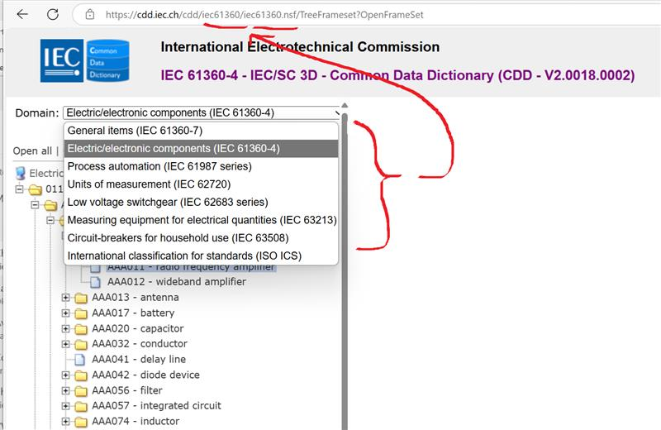

Figure 8‑1: Example of selecting a suitable IEC standard

**Step 3**: Search the selected tree for the suitable class and/or attribute manually via <https://cdd.iec.ch/cdd/iec61360/iec61360.nsf/TreeFrameset> or do a text search via <https://cdd.iec.ch/cdd/iec61360/iec61360.nsf/SearchFrameset>. E.g. if you want to find the IEC-ID for ‘temperature type’ (<https://cdd.iec.ch/cdd/iec61360/iec61360.nsf/TU0/0112-2---61360_4%23AAA032>), either scroll down the website or you can perform a text search via for the relevant word search. Click the suitable search result you find most accurately suits your search.

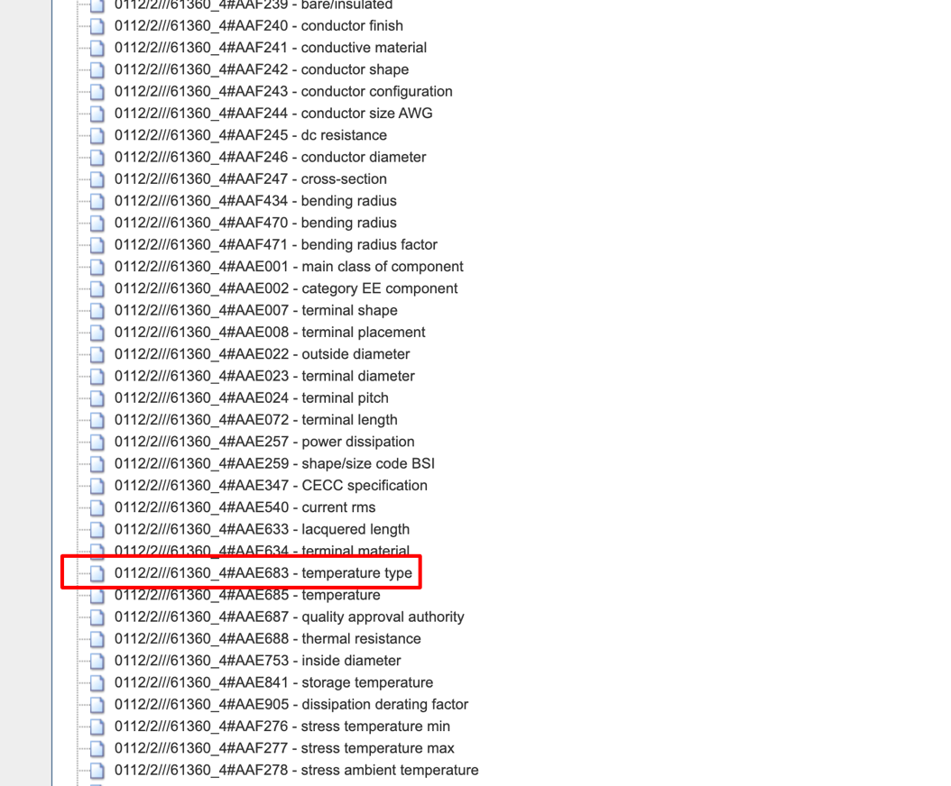

Figure 8‑2: Searching for IEC and IRDI IDs

**Step 4**: You will find the IEC IRDI for the selected property:

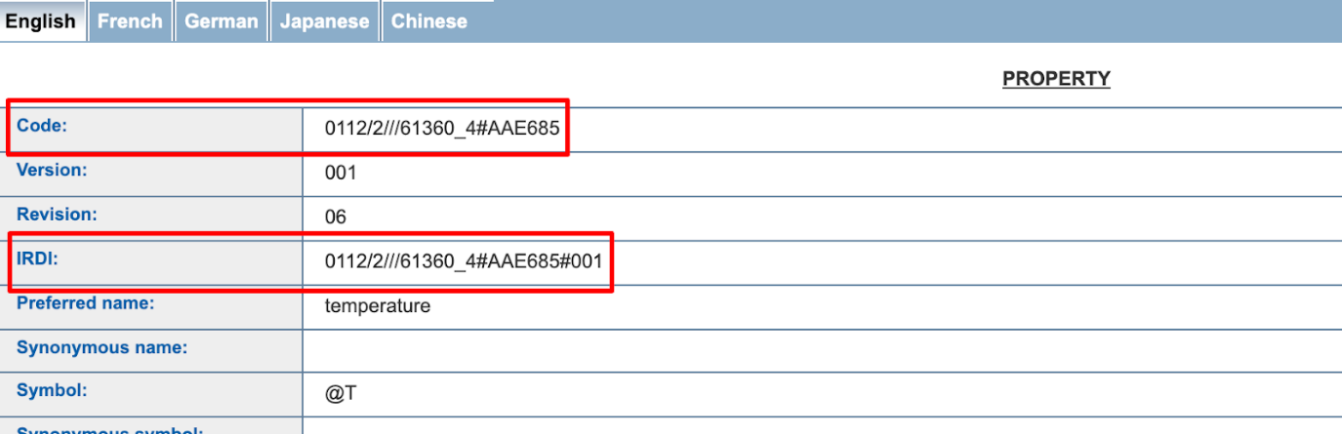

Figure 8‑3: IEC and IRDI Identification for a Property

#### Adding it to Semantic Description

**Step 1:** In the AAS Designer, click on the following option in semantic description under a specific subshell:

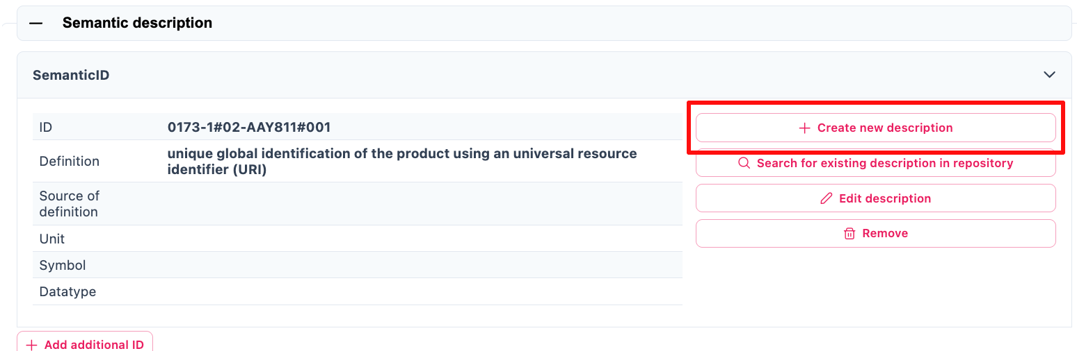

Figure 8‑4: Semantic description in the AAS Designer

**Step 2:** Add IRDI value to the ID and specify the industry standard used.

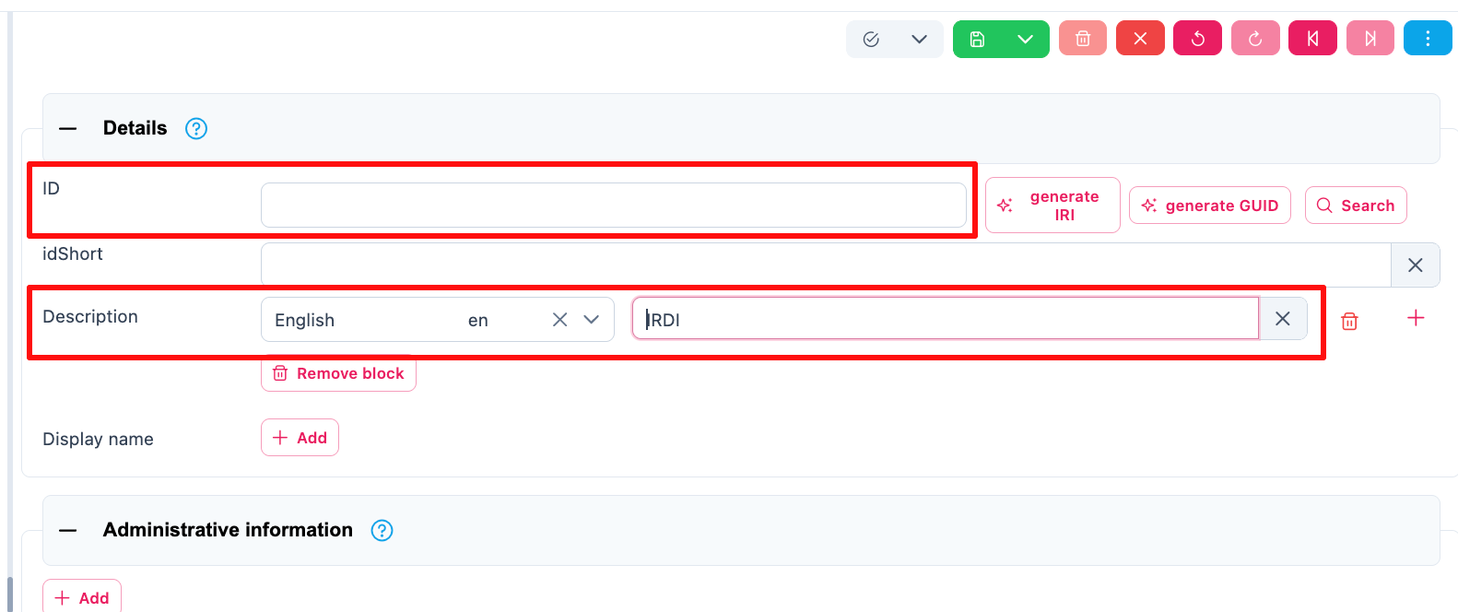

Figure 8‑5: ID and Description in Details of Semantic description

### ECLASS

ECLASS is an internationally recognized classification system that provides a standardized framework for describing products and services in all industries. It ensures that businesses, manufacturers, and suppliers use a common language when exchanging product information, regardless of language, country, or system.

ECLASS ensures consistent identification of product classes and properties across different languages and business ecosystems.

Click on the image below redirects to the website (<https://eclass.eu/en/eclass-standard/search-content>):

[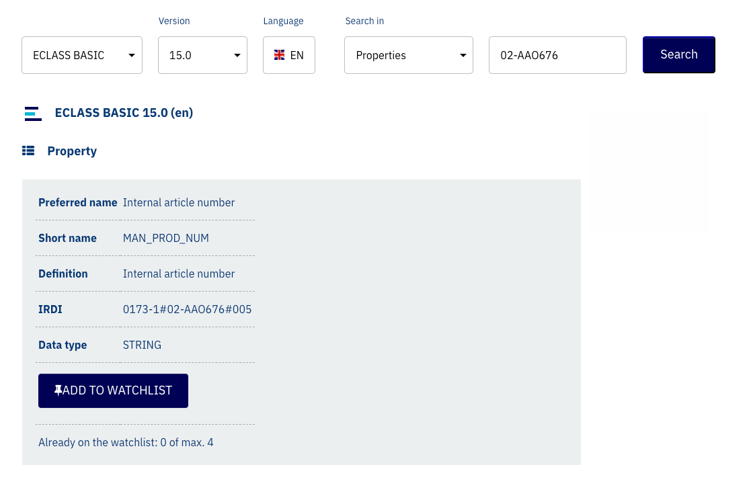](https://eclass.eu/en/eclass-standard/search-content)

Figure 8‑6: ECLASS Classification System

ECLASS elements are structured as follows:

|  |  |
| --- | --- |
| **Code Space Identifier (CSI)** | **Category of administrated item** |
| 44 | class |
| 04 | property |
| 01 | unit of measurement |
| 01 | property value |

*Table 1 Excerpt of Code Space Identifiers (CSI) according to ISO 290ß05-5*[4]

Informative Links to online element descriptions can be created as follows:

<https://eclass.eu/eclass-standard/content-suche/show?tx_eclasssearch_ecsearch%5Bid%5D=44040101>

ECLASS IRDIs are structured as follows:

|  |  |
| --- | --- |
| **Component** | **Meaning** |
| 0173 | Issuing agency (ECLASS) |
| 1 | ECLASS Office |
| 02 | Property (CSI Code) |
| BAA456 | Unique identifier of property |
| 001 | Version number |

*Table 4 Breakdown of IRDI Example (0173-1#02-BAA456#001)*

### VEC

The [Vehicle Electric Container (VEC)](https://ecad.prostep.org/ontologies/2024/03/vec)[5] is an example for an industry-standard data model designed for the exchange of electrical system information in the automotive and transportation sectors. It is developed and maintained by ProSTEP iViP, a consortium focused on interoperability in engineering data exchange.

VEC provides a structured format for representing and exchanging electrical wire harness data, including components, connections, signals, geometries, and metadata. Ist role is enabling seamless communication between different Computer-Aided Design (CAD) and Product Lifecycle Management (PLM) systems. VEC is defined in the VDA Recommendation 4968 and ProSTEP iViP Recommendation PSI21, in form of a standardized information model, data dictionary, XML schema, and an ontology in “[RDF 1.1 Turtle](https://www.w3.org/TR/turtle/#sec-iri-references)” syntax is provided at <https://ecad-wiki.prostep.org/specifications/vec/v210/vec-2.1.0-ontology.ttl>, which can be utilized in the AAS as follows:

* **Step 1**: Go to the website link: <https://ecad-wiki.prostep.org/specifications/vec/v210/vec-2.1.0-ontology.ttl>
* **Step 2**: Press Ctrl+F and search for the result you need. For eg. you are searching for information on temperature, you can search for “temperature”.
* **Step 3**: One of the result is shown below. So the relevant vec for my search is vec:TemperatureInformation.

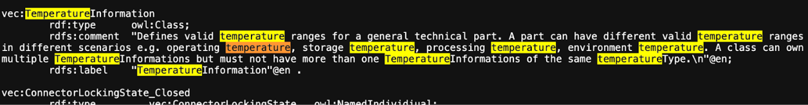

Figure 8‑7: Searching for Temperature Information in the VEC Model

To be used inside the AAS, a AAS-suitable ID formation must be defined, e.g. in the form of IRIs (Internationalized Resource Identifier):

Reference examples to class definitions:

http://www.prostep.org/ontologies/ecad/2024/03/vec#TemperatureType

http://www.prostep.org/ontologies/ecad/2024/03/vec#InsulationSpecification

Reference examples for value in enumeration:

http://www.prostep.org/ontologies/ecad/2024/03/vec#PrimaryPartType_Wire

http://www.prostep.org/ontologies/ecad/2024/03/vec#PrimaryPartType_PluggableTerminal  
http://www.prostep.org/ontologies/ecad/2024/03/vec#TemperatureType_AmbientTemperature

Reference examples on Properties:

http://www.prostep.org/ontologies/ecad/2024/03/vec#itemVersionCompanyName

http://www.prostep.org/ontologies/ecad/2024/03/vec#partVersionPrimaryPartType

http://www.prostep.org/ontologies/ecad/2024/03/vec#partVersionPartNumber

http://www.prostep.org/ontologies/ecad/2024/03/vec#partVersionPreferredUseCase

http://www.prostep.org/ontologies/ecad/2024/03/vec#insulationSpecificationBaseColor

http://www.prostep.org/ontologies/ecad/2024/03/vec#insulationSpecificationMaterial

http://www.prostep.org/ontologies/ecad/2024/03/vec#conductorSpecificationCrossSectionArea

http://www.prostep.org/ontologies/ecad/2024/03/vec#conductorSpecificationMaterial

http://www.prostep.org/ontologies/ecad/2024/03/vec#wireElementSpecificationMinBendRadiusStatic

#### NumericalValue (VEC) as a Property (AAS)

**Variant 1**: Define Unit in Concept Description

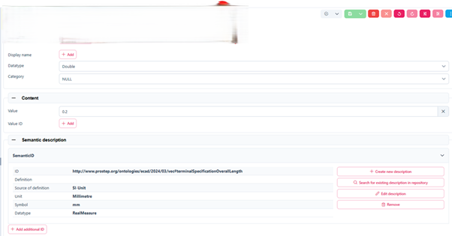

Figure 8‑8: For a VEC-NumericalValue define Unit in Concept Description

**Problem**:

- The unit (e.g. in m, mm, inches) is defined globally for the referenced VEC property for all AASes on the AAS server.

- When another unit format comes from a native source, it may be necessary to convert with rounding errors.

**Variant 2**: Create a concept description for each unit-property combination, e.g.

vec#thickness_m

vec#thickness_mm

vec#thickness_inches

Problems: Semantic reference between the CDs and the VEC specification would be lost.

**Variant 3**: Define unit for each property in the embedded data specification

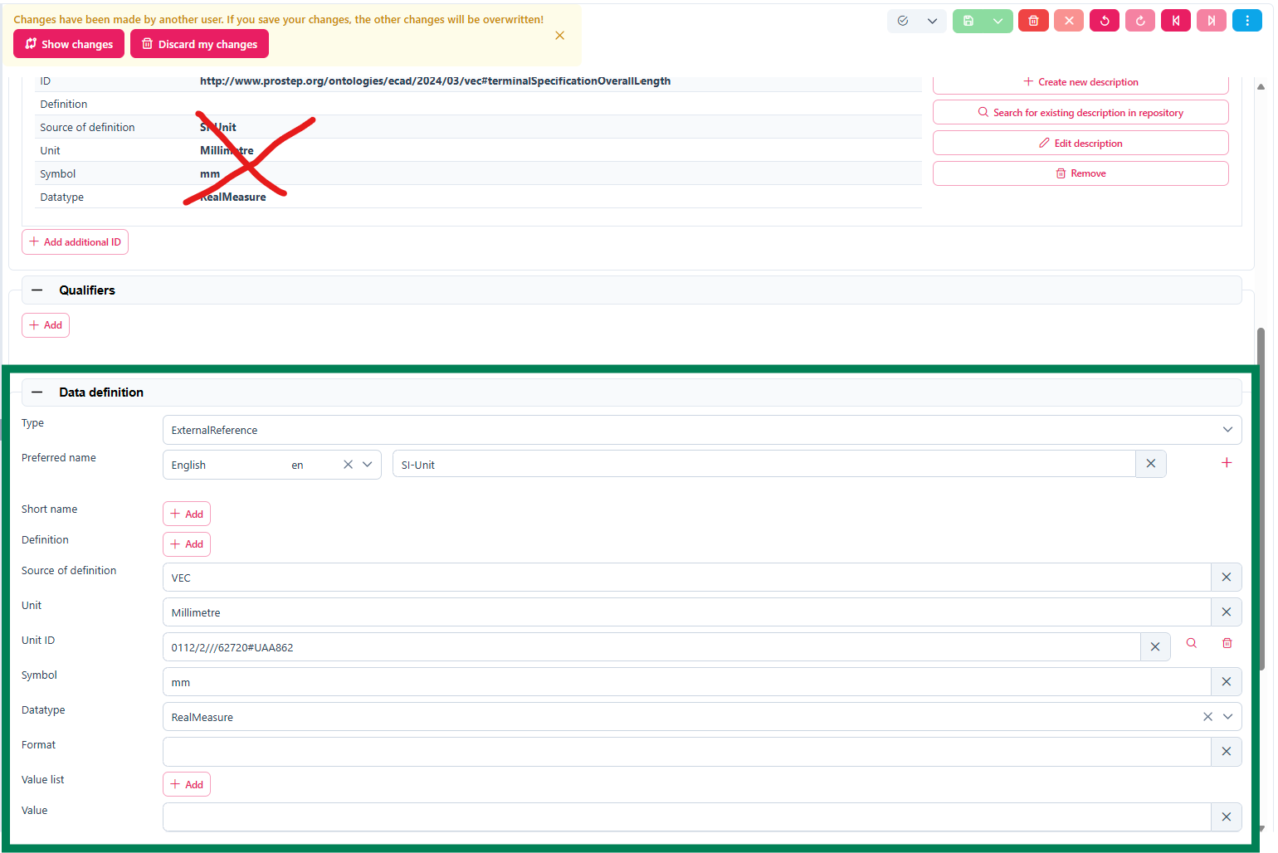

Figure 8‑9: Define Unit for each property in the embedded data specification

#### Mapping of predefined values from reference systems

VEC provides limited semantic definitions in some aspects. It can therefore be useful to combine other established reference systems. These often define attributes for dedicated topics such as colors, materials, protection classes, as for example in IEC-CDD:

|  |  |
| --- | --- |
| **Applicable properties:** | **Enumeration code list:** |
| [0112/2///61360_4#AAF250 - insulation colour code](https://cdd.iec.ch/cdd/iec61360/iec61360.nsf/PropertiesAllVersions/0112-2---61360_4%23AAF250?opendocument) [0112/2///61360_4#AAH065 - housing colour code](https://cdd.iec.ch/cdd/iec61360/iec61360.nsf/PropertiesAllVersions/0112-2---61360_4%23AAH065?opendocument) [0112/2///61360_7#CBA018 - IEC colour code of item](https://cdd.iec.ch/cdd/common/iec61360-7.nsf/PropertiesAllVersions/0112-2---61360_7%23CBA018?opendocument) | N.A., BK, BN, RD, OG, GN, YE, BU, VT, GY, WH, PK, GD, TQ, SR, GNYE, BKBN, BKRD, BKOG, BKGN, BKVT, BKGY, BKWH, BKPK, BKGD, BKTQ, BKSR, BRRD, BROG, BRBU, BRVT, BRGY, BRWH, BRPK, BRGD, BRTK, BRSR, RDOG, RDBU, RDVT, RDGY, RDWH, RDPK, RDGD, RDTQ, RDSR, OGBU, OGVT, OGGY, OGWH, OGPK, OGGD, OGTQ, OGSR, BUVT, BUGY, BUWH, BUPK, BUGD, BUTQ, BUSR, VTGY, VTWH, VTPK, VTGD, VTTQ, VTSR, GYWH, GYPK, GYGD, GYTQ, GYSR, WHPK, WHGD, WHTQ, WHSR, PKGD, PKTQ, PKSR, GDTQ, GDSR, TQSR, OTHERS |
| [0112/2///61360_4#AAF128 - package colour](https://cdd.iec.ch/cdd/iec61360/iec61360.nsf/PropertiesAllVersions/0112-2---61360_4%23AAF128?opendocument) | BG, BK, BL, BN, BZ, GN, GY, IV, NC, OR, PK, RD, TN, VT, WT, YL |
|  |  |
| [0112/2///61360_4#AAF243 - conductor configuration](https://cdd.iec.ch/cdd/iec61360/iec61360.nsf/PropertiesAllVersions/0112-2---61360_4%23AAF243?opendocument) | BRAID, BUNCH, LITZ, SOLID, STRAND, TINSEL |
| [0112/2///61360_4#AAJ018 - sealing class](https://cdd.iec.ch/cdd/iec61360/iec61360.nsf/PropertiesAllVersions/0112-2---61360_4%23AAJ018?opendocument) | DUSTP, OPEN, SEAL |
| [0112/2///61360_4#AAH056 - body insulation material](https://cdd.iec.ch/cdd/iec61360/iec61360.nsf/PropertiesAllVersions/0112-2---61360_4%23AAH056?opendocument) | CER, GLS, PLA |
| [0112/2///61360_4#AAF248 - insulating material](https://cdd.iec.ch/cdd/iec61360/iec61360.nsf/PropertiesAllVersions/0112-2---61360_4%23AAF248?opendocument) | ECTFE, ENAM, E/TFE, FEP, PA, PAPER, PE, PFA, POLY, PP, PTFE, PUR, PVC, RUBBER, TEXTILE, UP |
| [0112/2///61360_4#AAF241 - conductive material](https://cdd.iec.ch/cdd/iec61360/iec61360.nsf/PropertiesAllVersions/0112-2---61360_4%23AAF241?opendocument) | Al, Cu, CuCd, CuCdCr, CuCr, CuNi, CuSn, CuZn, Fe/Cu |
| [0112/2///61360_4#AAF240 - conductor finish](https://cdd.iec.ch/cdd/iec61360/iec61360.nsf/PropertiesAllVersions/0112-2---61360_4%23AAF240?opendocument) | Ag, Ni, Sn |
| [0112/2///61360_4#AAR025 - contact material](https://cdd.iec.ch/cdd/iec61360/iec61360.nsf/PropertiesAllVersions/0112-2---61360_4%23AAR025?opendocument) | Ag, AgCdO, AgCdO/Au, AgNi, AgNi/Au, AgPd, AgPd/Au, AgSnO2, AgSnO2/Au, AgW, Ag/Au, AuAg, PdCu, PdNi, Rh, Rh/Au, W |
| [0112/2///61360_4#AAE355 - contact body material](https://cdd.iec.ch/cdd/iec61360/iec61360.nsf/PropertiesAllVersions/0112-2---61360_4%23AAE355?opendocument) | BeCu, Cu, CuSn, CuZn, Ni, PCuSn |
| [0112/2///61360_4#AAE350 - contact finish](https://cdd.iec.ch/cdd/iec61360/iec61360.nsf/PropertiesAllVersions/0112-2---61360_4%23AAE350?opendocument) | Ag, Au, CuZn, Ni, PCuSn, Pd, Sn, Zn |
| [0112/2///61360_4#AAE351 - housing material](https://cdd.iec.ch/cdd/iec61360/iec61360.nsf/PropertiesAllVersions/0112-2---61360_4%23AAE351?opendocument) | CER, DAP, MET, PA, PC, PLA, PPOX, PTFE |
| [0112/2///61360_4#AAH005 - housing finish](https://cdd.iec.ch/cdd/iec61360/iec61360.nsf/PropertiesAllVersions/0112-2---61360_4%23AAH005?opendocument) | Ag, Au, Cr, ELOX, LAC, Ni, PLA, RAW, RUB, Sn, Zn |
| [0112/2///61360_4#AAE634 - terminal material](https://cdd.iec.ch/cdd/iec61360/iec61360.nsf/PropertiesAllVersions/0112-2---61360_4%23AAE634?opendocument) | AgPd, NiSn |
| [0112/2///61360_4#AAH028 - terminal finish](https://cdd.iec.ch/cdd/iec61360/iec61360.nsf/PropertiesAllVersions/0112-2---61360_4%23AAH028?opendocument) | Ag, Au, Cr, Ni, Pd, RAW, Sn |
| [0112/2///61360_4#AAH011 - designation of IP protection](https://cdd.iec.ch/cdd/iec61360/iec61360.nsf/PropertiesAllVersions/0112-2---61360_4%23AAH011?opendocument) [0112/2///61360_7#CBA025 - IP code](https://cdd.iec.ch/cdd/common/iec61360-7.nsf/PropertiesAllVersions/0112-2---61360_7%23CBA025?opendocument) [0112/2///61987#ABA558 - degree of protection (IP)](https://cdd.iec.ch/cdd/iec61987/iec61987.nsf/PropertiesAllVersions/0112-2---61987%23ABA558?opendocument) | IP00, IP01, IP02, IP03, IP04, IP05, IP06, IP07, IP08, IP10, IP11, IP12, IP13, IP14, IP15, IP16, IP17, IP18, IP20, IP21, IP22, IP23, IP24, IP25, IP26, IP27, IP28, IP30, IP31, IP32, IP33, IP34, IP35, IP36, IP37, IP38, IP40, IP41, IP42, IP43, IP44, IP45, IP46, IP47, IP48, IP50, IP51, IP52, IP53, IP54, IP55, IP56, IP57, IP58, IP60, IP61, IP62, IP63, IP64, IP65, IP66, IP67, IP68, IP69, IPX1, IPX2, IPX3, IPX4, IPX5, IPX6, IPX7, IPX8, IP1X, IP2X, IP3X, IP4X, IP5X, IP6X |

# **Best Practice for Semantic References**

The AAS provides several ways to add semantic references to its entities. Both this variety and different existing reference systems lead to some uncertainty on how to do it. We want to propose the best practice described in the following.

## “Semantic Description”

Next up the Semantic description can be added. It must be noted that this leads to the creation of a so called “Concept Description” (CD), which is a stand-alone semantic reference element that can be referenced by other property definitions as well, even from outside the AAS.

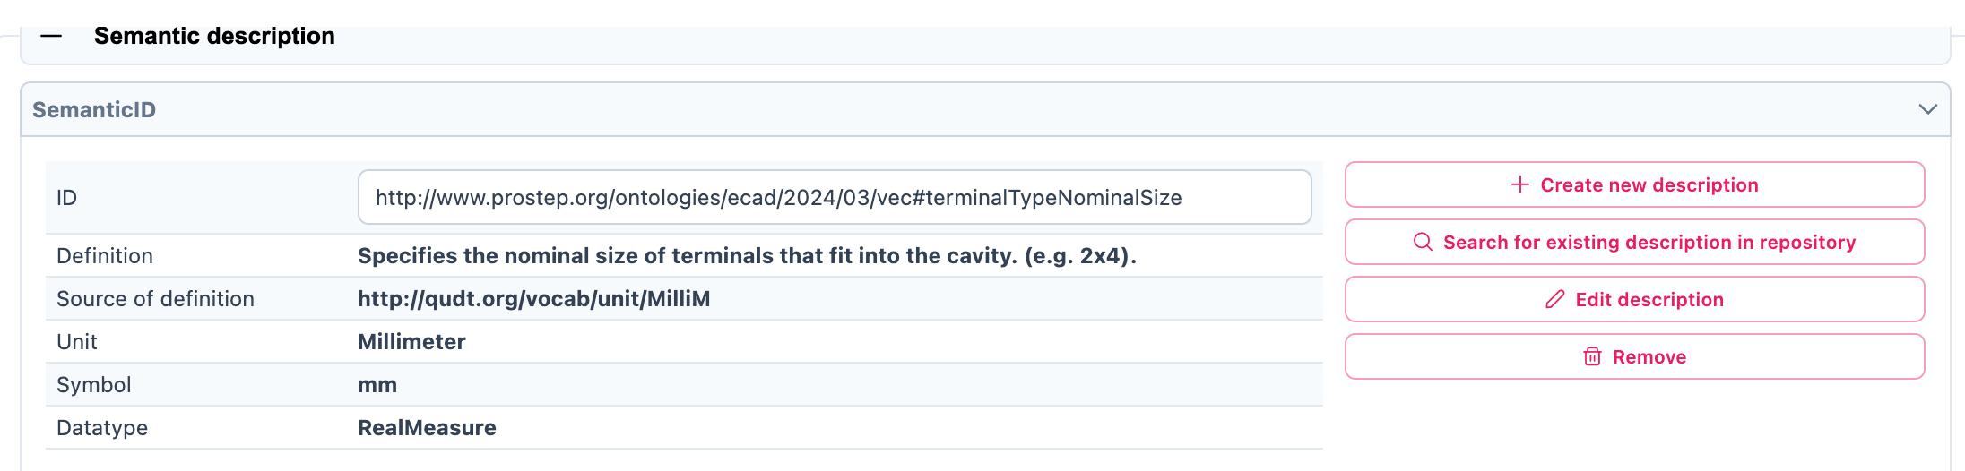

Figure 9‑1: Filled in Semantic description

This contrasts with the “Qualifiers” and “Data Definitions”, which are directly embedded in the property definition.

## “Qualifier”

Additional definitions for a property can be done via the “Qualifier” concept, i.e. definition of Upper- and Lower-Boundaries as shown below:



Figure 9‑2: Example of a filled in Qualifier

Qualifiers in the Asset Administration Shell (AAS) provide additional metadata about elements, acting as type-value pairs that define properties related to value, semantics, or existence.

There are three main types: **ValueQualifier**, which describes how a value was determined (e.g., "measured" or "substitute value" for temperature); **ConceptQualifier**, which differentiates semantically similar elements based on lifecycle stages (e.g., "as planned" vs. "as maintained" for a Bill of Material); and **TemplateQualifier**, which defines whether a submodel element is "mandatory" or "optional." Constraints ensure consistency, such as AASd-006, which requires a qualifier’s *value* and *valueId* to be identical if both are present, and AASd-020, which enforces data type consistency. In terms of referencing, AAS elements can be **identifiable** (globally unique ID), **referable** (having an *idShort* within a namespace), or **neither** (such as qualifiers, which are attributes). A referable element's namespace is determined by its parent, ensuring structured relationships, such as a submodel serving as the namespace for its contained properties.

Definitions from the AASXPE can be found here: <https://github.com/admin-shell-io/aasx-package-explorer/blob/main/src/AasxPackageExplorer/qualifier-presets.json>

## Submodel

Any IDTA submodel template comes with a semantic reference on its own which should not be changed. When a proprietary submodel is created, it is recommended to also create a dedicated submodel template id with the potential capability to be used as a reference by others.

In the below figure, as discussed earlier IDTA’s HandoverDocumentation is the Submodel.

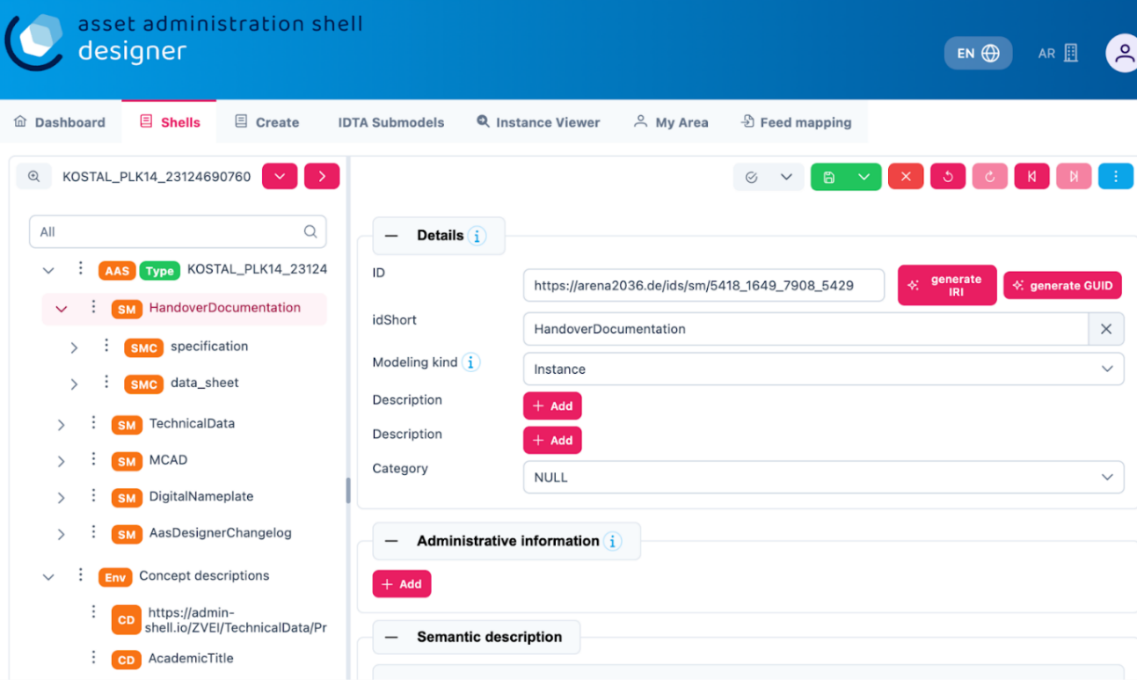

Figure 9‑3: Adding Semantic References in AAS Designer

To add semantic reference to HandoverDocumentation, follow the following steps:

* 1. Either search for an existing description in the repository, but in our case there is no description available so let’s create a new description.

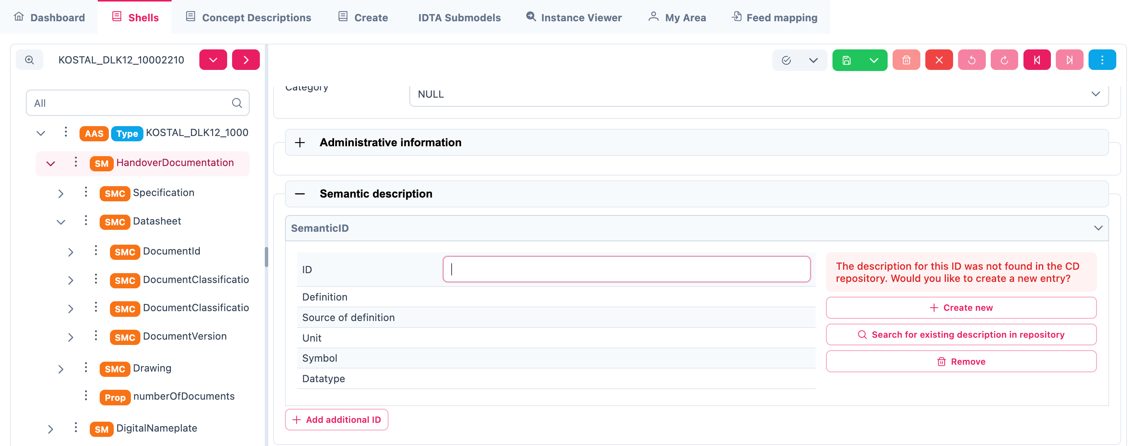

Figure 9‑4: Creating a New Semantic Description in AAS Designer

* 1. Add the relevant ECLASS/IEC/IRDI/VEC ID to the ID placeholder.
  2. Click Save

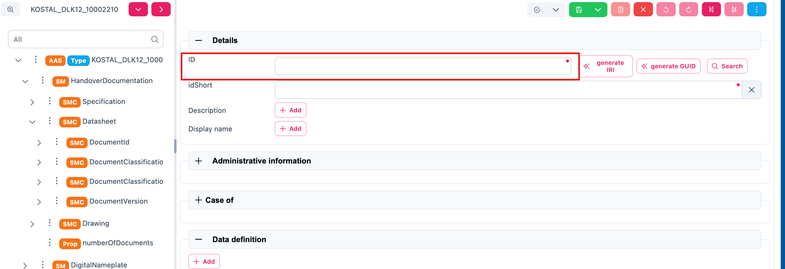

Figure 9‑5: Adding ECLASS/IEC/IRDI/VEC ID to the ID Placeholder

## Submodel Element Collection (SMC)

SMCs are a structuring element to hierarchically group other SMCs and/or properties inside a SM. Sometimes it can make sense to also semantically reference an SMC, especially when the SMC reflects a datamodel that was defined outside the AAS.

## Property

Any Property in an AAS that has its definition source in an outside system that can be referenced, should be referenced. Properties defined in IDTA templates usually come with semantic reference information pointing to ECLASS and/or IEC. Such semantic references should not be changed. When a proprietary property is created in an AAS, it is recommended to also attach semantic references to them and create its id with the potential capability to be used as a reference by others.

In the below figure, ‘specification’ is the property. Follow the same steps as above.

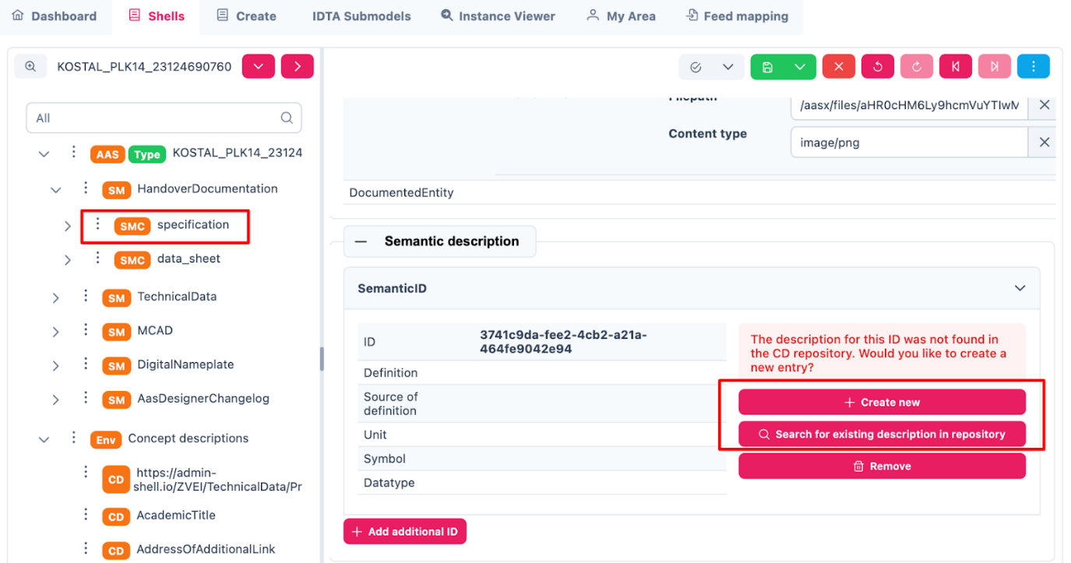

Figure 9‑6: Defining a Property in AAS Designer

## Property Value

Sometimes even property values are defined in semantic reference systems and should therefore be used and tagged with reference information in the associated *ValueId*. Typical examples are color codes, IP codes etc. which are defined in several reference systems like ECLASS and IEC.

In the below figure, ‘DocumentId’ is the property value. Follow the same steps as above.

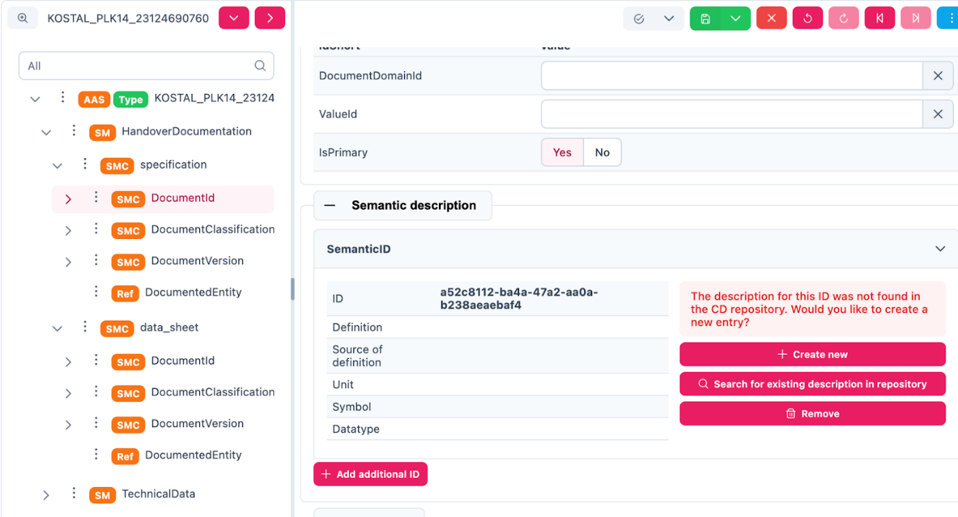

Figure 9‑7: Assigning a Property Value in AAS Designer

# **Concept Description**

An Asset Administration Shell (AAS) can have its own dictionary of sematic references where it defines the meanings of different elements inside it. These elements are called Concept Descriptions. A Concept Description (CD) in the context of the Asset Administration Shell (AAS) defines the semantic meaning of the elements within its submodels. A CD utilizes basically the same elements

There are three types:

1. AASIrdiConceptDescriptionType – Based on international reference dictionaries using IRDI (International Registration Data Identifier).
2. AASIriConceptDescriptionType – Uses URI (Uniform Resource Identifier) for referencing.
3. AASCustomConceptDescriptionType – Custom definitions created by the user.

The semanticId links the submodel elements to the corresponding semantic definitions, which are referenced via the HasDictionaryEntry relation. Also the concept description can include Add-Ins, allowing the use of IEC61360 data specification templates, which standardize how asset-related data, like units or value ranges, is represented. In OPC UA (Open Platform Communications Unified Architecture), the different ConceptDescription types used in the Asset Administration Shell (AAS) are placed under the standard Dictionaries folder. The concept descriptions help clarify the meaning of data, ensuring accurate interpretation across systems.

In the figure below, ‘AcademicTitle’ is the property value. Follow the same steps as above.

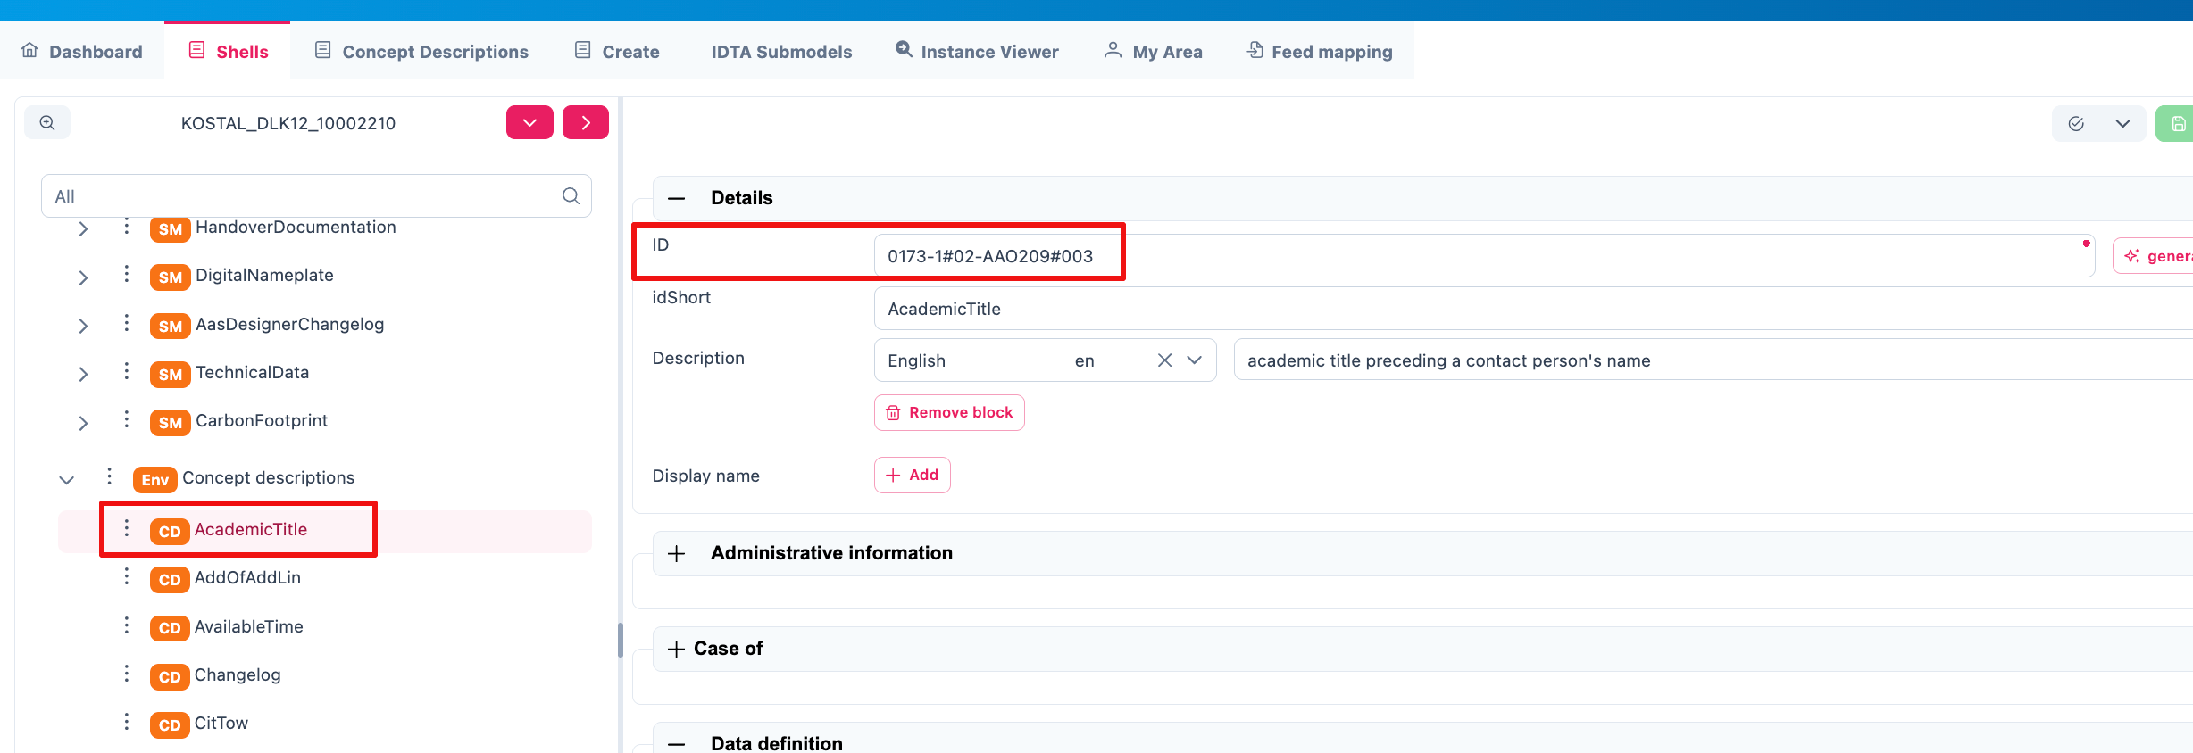

Figure 10‑1: Concept Description in AAS Designer

# Literaturverzeichnis

|  |  |
| --- | --- |
| [1] | Industrial Digital Twin Association e.V., „IDTA 02004-1-2 Handover Documentation,“ March 2023. [Online]. Available: https://github.com/admin-shell-io/submodel-templates/tree/main/published/Handover%20Documentation/1/2. |
| [2] | Industrial Digital Twin Association e.V., „IDTA 02003-1-2 Generic Frame for Technical Data for Industrial Equipment in Manufacturing,“ August 2022. [Online]. Available: https://github.com/admin-shell-io/submodel-templates/tree/main/published/Technical_Data/1/2. |
| [3] | Industrial Digital Twin Association e.V., „IDTA 02006-2-0 Digital Nameplate for Industrial Equipment,“ October 2022. [Online]. Available: https://github.com/admin-shell-io/submodel-templates/tree/main/published/Digital%20nameplate/2/0. |
| [4] | ARENA2036 e.V., „VWS4LS-Github,“ [Online]. Available: https://github.com/VWS4LS. |
| [5] | Plattform Industrie 4.0, „Verwaltungsschale in der Praxis,“ 2021. [Online]. Available: https://industrialdigitaltwin.org/wp-content/uploads/2021/09/08_verwaltungsschale_in_der_praxis_de_2020.pdf. |
| [6] | Plattform Industrie 4.0, „Vertrauensinfrastrukturen,“ 03 2021. [Online]. Available: https://www.plattform-i40.de/IP/Redaktion/DE/Downloads/Publikation/Vertrauensinfrastrukturen.pdf. |
| [7] | „Verband der Automobilindustrie (VDA),“ [Online]. Available: https://www.vda.de/de. |
| [8] | Prostep ivip e.V., „Vehicle Electric Container (VEC),“ 8 Jan 2024. [Online]. Available: https://ecad-wiki.prostep.org/specifications/vec/v210/. |
| [9] | Prostep ivip e.V., „VEC Release Notes - Version 2.1.0,“ 08 01 2024. [Online]. Available: https://ecad-wiki.prostep.org/specifications/vec/v210/release-notes/. |
| [10] | VDI/VDE, „VDI/VDE 2193 Blatt 2 - Sprache für I4.0-Komponenten - Interaktionsprotokoll für Ausschreibungsverfahren,“ 2020. [Online]. Available: https://www.vdi.de/richtlinien/details/vdivde-2193-blatt-2-sprache-fuer-i40-komponenten-interaktionsprotokoll-fuer-ausschreibungsverfahren. |
| [11] | VDI/VDE, „VDI/VDE 2193 Blatt 1 - Sprache für I4.0-Komponenten - Struktur von Nachrichten,“ 2020. [Online]. Available: https://www.vdi.de/richtlinien/details/vdivde-2193-blatt-1-sprache-fuer-i40-komponenten-struktur-von-nachrichten. |
| [12] | ECLASS e.V., „Technical Specification Conceptual Data Model,“ 2020. [Online]. Available: https://eclass.eu/fileadmin/Redaktion/pdf-Dateien/Wiki/ECLASS_Technical-Specification_11_Conceptual-Data-Model_v_1.0.pdf. |
| [13] | Wikipedia, „Single Point of Truth,“ [Online]. Available: https://de.wikipedia.org/wiki/Single_Point_of_Truth. |
| [14] | Industrial Digital Twin Association e.V., „Registrierte IDTA Submodelle,“ [Online]. Available: https://industrialdigitaltwin.org/en/content-hub/submodels. |
| [15] | Platform Industrie 4.0, „RAMI 4.0: Ein Referenzarchitekturmodell als Kommunikationsgrundlage in der Industrie 4.0,“ 11 04 2022. [Online]. Available: https://www.dke.de/de/arbeitsfelder/industry/rami40. |
| [16] | „Prostep ivip e.V.,“ [Online]. Available: https://www.prostep.org/. |
| [17] | „OPC UA Online Reference - Released Specifications,“ 2024. [Online]. Available: https://reference.opcfoundation.org/. |
| [18] | OPC Foundation, „OPC UA Nodesets,“ [Online]. Available: https://github.com/OPCFoundation/UA-Nodeset. |
| [19] | KEBA, „OPC UA – der zentrale Standard für Industrie 4.0 im Überblick,“ [Online]. Available: https://www.keba.com/de/news/industrial-automation/ueberblick-opc-ua-zentraler-standard-industrie-4-0. |
| [20] | OPC Foundation, „OPC 40570: OPC UA for the Wire Harness Manufacturing Industry,“ https://profiles.opcfoundation.org/workinggroup/88, WiP. [Online]. Available: https://profiles.opcfoundation.org/document/214. |
| [21] | OPC Foundation, „OPC 40001-3: Machinery Job Mgmt,“ OPC Foundation, [Online]. Available: https://reference.opcfoundation.org/Machinery/Jobs/v100/docs/. |
| [22] | OPC Foundation, „OPC 40001-101: Machinery Result Transfer,“ [Online]. Available: https://reference.opcfoundation.org/Machinery/Result/v100/docs/. |
| [23] | OPC Foundation, „OPC 30270: Industry 4.0 Asset Administration Shell,“ [Online]. Available: https://reference.opcfoundation.org/I4AAS/v100/docs/. |
| [24] | OPC Foundation, „OPC 10031-4: ISA-95-4 Job Control,“ [Online]. Available: https://reference.opcfoundation.org/ISA95JOBCONTROL/v200/docs/. |
| [25] | OPC Foundation, „OPC 10000-210: Industrial automation - Relative Spatial Location,“ 2023. [Online]. Available: https://reference.opcfoundation.org/RSL/v100/docs/. |
| [26] | VDI 2860, „Montage- und Handhabungstechnik; Handhabungsfunktionen, Handhabungseinrichtungen; Begriffe, Definitionen, Symbole,“ Beuth Verlag, Berlin, 1990. |
| [27] | ISO, „ISO/IEC 27002:2022-02: Information security, cybersecurity and privacy protection - Information security controls,“ 2022. [Online]. Available: https://www.iso.org/standard/75652.html. |
| [28] | ISO, „ISO/IEC 27001:2022 Information security, cybersecurity and privacy protection — Information security management systems — Requirements,“ [Online]. Available: https://www.iso.org/standard/27001. |
| [29] | ISO/IEC, „ISO/IEC 19510:2013: Business Process Model and Notation (BPMN),“ [Online]. Available: https://www.iso.org/standard/62652.html. |
| [30] | Plattform Industrie 4.0, „Interoperability at Runtime - Exchanging Information via Application Programming Interfaces,“ 2021. [Online]. Available: https://www.plattform-i40.de/IP/Redaktion/EN/Downloads/Publikation/Details_of_the_Asset_Administration_Shell_Part2_V1.pdf. |
| [31] | IEC, „IEC 61360-4 - IEC/SC 3D - Common Data Dictionary,“ [Online]. Available: https://cdd.iec.ch/cdd/iec61360/iec61360.nsf/TreeFrameset?OpenFrameSet. |
| [32] | Industrial Digital Twin Association e.V., „IDTA 02056-1-0 Data Retention Policies,“ June 2024. [Online]. Available: https://industrialdigitaltwin.org/wp-content/uploads/2024/06/IDTA-02056-1-0_Submodel_Data-Retention-Policies.pdf. |
| [33] | Industrial Digital Twin Association e.V., „IDTA 02051 Purchase Request Notification,“ (WiP). [Online]. Available: https://interopera.de/wp-content/uploads/2024/02/231113-Abschlusspraesentation-InterOpera-Purchase-Teilmodelle-Liedl.pdf. |
| [34] | Industrial Digital Twin Association e.V., „IDTA 02048 Predictive Maintenance,“ (WiP). [Online]. Available: https://interopera.de/wp-content/uploads/2023/07/230705-Predictive-Maintenance-Abschlusspraesentation.pdf. |
| [35] | Industrial Digital Twin Association e.V., „IDTA 02031-1-0 Bill of Process,“ (WiP). [Online]. Available: https://industrialdigitaltwin.org/content-hub/teilmodelle. |
| [36] | Industrial Digital Twin Association e.V., „IDTA 02026-1-0 Provision of 3D Models,“ June 2024. [Online]. Available: https://github.com/admin-shell-io/submodel-templates/tree/main/published/Provision%20of%203D%20Models/1/0. |
| [37] | Industrial Digital Twin Association e.V., „IDTA 02020-1-0 Capability Description,“ (WiP). [Online]. Available: https://industrialdigitaltwin.org/content-hub/teilmodelle. |
| [38] | Industrial Digital Twin Association e.V., „IDTA 02017-1-0 Asset Interfaces Description,“ January 2024. [Online]. Available: https://github.com/admin-shell-io/submodel-templates/tree/main/published/Asset%20Interfaces%20Description/1/0. |
| [39] | Industrial Digital Twin Association e.V., „IDTA 02011-1-1 Hierarchical Structures enabling Bills of Material,“ 2024 June. [Online]. Available: https://github.com/admin-shell-io/submodel-templates/tree/main/published/Hierarchical%20Structures%20enabling%20Bills%20of%20Material/1/1. |
| [40] | Industrial Digital Twin Association e.V., „IDTA 02010-1-0 Service Request Notification,“ October, 2023. [Online]. Available: https://github.com/admin-shell-io/submodel-templates/tree/main/published/Service%20Request%20Notification/1/0. |
| [41] | Industrial Digital Twin Association e.V., „IDTA 02008-1-1 Time Series Data,“ 2023. [Online]. Available: https://github.com/admin-shell-io/submodel-templates/tree/main/published/Time%20Series%20Data/1/1. |
| [42] | Industrial Digital Twin Association e.V., „IDTA 02005-1-0 Provision of Simulation Models,“ December 2022. [Online]. Available: https://github.com/admin-shell-io/submodel-templates/tree/main/published/Provision of Simulation Models/1/0. |
| [43] | Industrial Digital Twin Association e.V., „IDTA 02002-1-0 Submodel for Contact Information,“ May 2022. [Online]. Available: https://github.com/admin-shell-io/submodel-templates/tree/main/published/Contact%20Information/1. |
| [44] | Industrial Digital Twin Association e.V., „IDTA 01005-3-0-1: Specification of the Asset Administration Shell Part 5: Package File Format (AASX),“ 2024. [Online]. Available: https://admin-shell-io.github.io/aas-specs-antora/IDTA-01005/v3.0.1/index.html. |
| [45] | Industrial Digital Twin Association e.V., „IDTA 01002-3-0-2: Specification of the Asset Administration Shell Part 2: Application Programming Interfaces,“ June 2024. [Online]. Available: https://admin-shell-io.github.io/aas-specs-antora/IDTA-01002/v3.0.2/index.html. |
| [46] | Industrial Digital Twin Association e.V., „IDTA 01001-3-0-1: Specification of the Asset Administration Shell Part 1: Metamodel,“ June 2024. [Online]. Available: https://admin-shell-io.github.io/aas-specs-antora/IDTA-01001/v3.0.1/index.html. |
| [47] | Prostep ivip e.V., „Harness Description List (KBL),“ prostep ivip, 26 Jun 2022. [Online]. Available: https://ecad-wiki.prostep.org/specifications/kbl/. |
| [48] | Wikipedia, „ETL-Prozess,“ 2024. [Online]. Available: https://de.wikipedia.org/wiki/ETL-Prozess. |
| [49] | ECLASS e.V., „ECLASS-Standard,“ [Online]. Available: https://eclass.eu/eclass-standard/content-suche/search. |
| [50] | „DIN SPEC 91345:2016-04 - Referenzarchitekturmodell Industrie 4.0 (RAMI4.0),“ 2016. [Online]. Available: https://dx.doi.org/10.31030/2436156. |
| [51] | IEC, „DIN EN IEC 61406-2 Identifizierungslink Teil 2: Typen/Modelle, Lose/Chargen, Artikel und Merkmale,“ 12 2024. [Online]. Available: https://www.vde-verlag.de/normen/0800994/din-en-iec-61406-2-vde-0810-407-2024-12.html. |
| [52] | IEC, „DIN EN IEC 61406-1 Identifizierungslink Teil 1: Allgemeine Anforderungen,“ 12 2023. [Online]. Available: https://www.vde-verlag.de/normen/0800916/din-en-iec-61406-1-vde-0810-406-1-2023-12.html. |
| [53] | „DIN 72036:2024-06 Straßenfahrzeuge - Automatisierung der Leitungssatzfertigung,“ DIN-Normenausschuss Auto und Mobilität, 06 2024. [Online]. Available: https://dx.doi.org/10.31030/3521962. |
| [54] | Wikipedia, „Digitaler Zwilling,“ 2024. [Online]. Available: https://de.wikipedia.org/wiki/Digitaler_Zwilling. |
| [55] | Plattform Industrie 4.0, „Digitale Ökosysteme global gestalten,“ 2019. [Online]. Available: https://www.plattform-i40.de/IP/Redaktion/DE/Downloads/Publikation/Leitbild-2030-f%C3%BCr-Industrie-4.0.pdf. |
| [56] | Industrial Digital Twin Association e.V., „Decentralized Registries: Taxonomy of decentralized registries and an architectural overview,“ June 2023. [Online]. Available: https://industrialdigitaltwin.org/en/wp-content/uploads/sites/2/2023/06/Decentralized-Registries-Taxonomy-of-decentralized-registries-and-an-architectural-overview_.pdf. |
| [57] | Plattform Industrie 4.0, „Capabilities, Skills, Services,“ 11 2022. [Online]. Available: https://www.plattform-i40.de/IP/Redaktion/DE/Downloads/Publikation/CapabilitiesSkillsServices.pdf?. |
| [58] | Plattform Industrie 4.0, „Beziehungen zwischen I4.0-Komponenten – Verbundkomponenten und intelligente Produktion,“ 2017. [Online]. Available: https://www.plattform-i40.de/IP/Redaktion/DE/Downloads/Publikation/beziehungen-i40-komponenten.pdf. |

# List of Figures

Figure 1‑1: Accessing AAS Designer via Google Search 4

Figure 1‑2: Navigating to the AAS Suite Designer 4

Figure 1‑3: Logging into the AAS Suite Designer 5

Figure 1‑4: Screenshot of Pricing and Terms in AAS Suite 5

Figure 1‑5: Registration Page for AAS Suite 6

Figure 1‑6: Accessing AAS Suite Version Details 6

Figure 1‑7: AAS Suite Version Information 7

Figure 1‑8: AAS Suite License Information 7

Figure 2‑1: Overview of AAS Suite Platform 8

Figure 2‑2: Key Components in AAS-Designer 8

Figure 3‑1: AAS Suite Dashboard Section 9

Figure 3‑2: Packages Section in AAS Suite 9

Figure 3‑4: IDTA Submodels in AAS Suite 10

Figure 3‑3: Creating a New Asset Administration Shell (AAS) 11

Figure 3‑5: My Area Section in AAS Suite 12

Figure 4‑1: List of shells in other servers 14

Figure 4‑2: Server Configuration for Admin 15

Figure 4‑3: Server Configuration for different Authority Role 16

Figure 5‑1: Overview of Shells 17

Figure 5‑2:Understanding Tree Structure in AAS Designer 18

Figure 5‑3: Expanding the Tree Structure in AAS Designer 18

Figure 5‑4: Inserting Elements in the AAS Designer 19

Figure 5‑5: Three dot menu in the pre hierarchy 20

Figure 5‑6: Adding new elements 21

*Figure 5‑7: Options of* *Elements* 21

*Figure 5‑8: Adding new Element* 22

*Figure 5‑9: Details section area* 24

*Figure 5‑10: Content section area* 24

*Figure 5‑11: Semantic description area* 24

*Figure 5‑12: Qualifier area* 25

*Figure 5‑13: Data definition area* 25

*Figure 5‑14: Example of a filled in Data definition* 26

*Figure 5‑15: Content part of Range* 27

*Figure 5‑16: Example of a listing in the Content part* 28

*Figure 5‑17: Custom Qualifier of SubmodelElementCollection* 29

*Figure 5‑18: Cardinality Qualifier of SubmodelElementCollection* 29

Figure 6‑1: Managing Asset Administration Shells (AAS) in AAS Suite 30

Figure 6‑2: AAS Shell Management Options 31

Figure 6‑3: Viewing Detailed Information of an AAS Shell 31

Figure 6‑4: Modifying an AAS Shell in AAS Designer 32

Figure 6‑5: Validation Errors in AAS Designer 33

Figure 6‑6: Resolving Validation Errors in AAS Designer 33

Figure 6‑7: Advanced Options in AAS Designer 34

Figure 6‑8: Creating Feed Mapping in AAS Designer 34

Figure 6‑9: Exporting AAS Data in AAS Designer 35

Figure 6‑10: Creating a Shareable Link in AAS Designer 35

Figure 6‑11: Configuring a Shareabale Link in AAS Designer 35

Figure 7‑1: Identification Schema According to ISO 29005-5 38

Figure 8‑1: Example of selecting a suitable IEC standard 42

Figure 8‑2: Searching for IEC and IRDI IDs 43

Figure 8‑3: IEC and IRDI Identification for a Property 43

Figure 8‑4: Semantic description in the AAS Designer 44

Figure 8‑5: ID and Description in Details of Semantic description 44

Figure 8‑6: ECLASS Classification System 45

Figure 8‑7: Searching for Temperature Information in the VEC Model 46

Figure 8‑8: For a VEC-NumericalValue define Unit in Concept Description 47

Figure 8‑9: Define Unit for each property in the embedded data specification 47

Figure 9‑1: Filled in Semantic description 49

Figure 9‑2: Example of a filled in Qualifier 50

Figure 9‑3: Adding Semantic References in AAS Designer 51

Figure 10‑2: Creating a New Semantic Description in AAS Designer 51

Figure 10‑3: Adding ECLASS/IEC/IRDI/VEC ID to the ID Placeholder 52

Figure 9‑6: Defining a Property in AAS Designer 52

Figure 9‑7: Assigning a Property Value in AAS Designer 53

Figure 10‑1: Concept Description in AAS Designer 54

1. <https://de.wikipedia.org/wiki/Universally_Unique_Identifier>
2. <https://eclass.eu/fileadmin/Redaktion/pdf-Dateien/Wiki/ECLASS-BMEcat-Guideline-2005_1_v2_1.pdf>
3. <https://reference.opcfoundation.org/Core/Part19/v105/docs/5.3>
4. <https://eclass.eu/fileadmin/Redaktion/pdf-Dateien/Wiki/ECLASS-BMEcat-Guideline-2005_1_v2_1.pdf>
5. <https://ecad.prostep.org/ontologies/2024/03/vec>